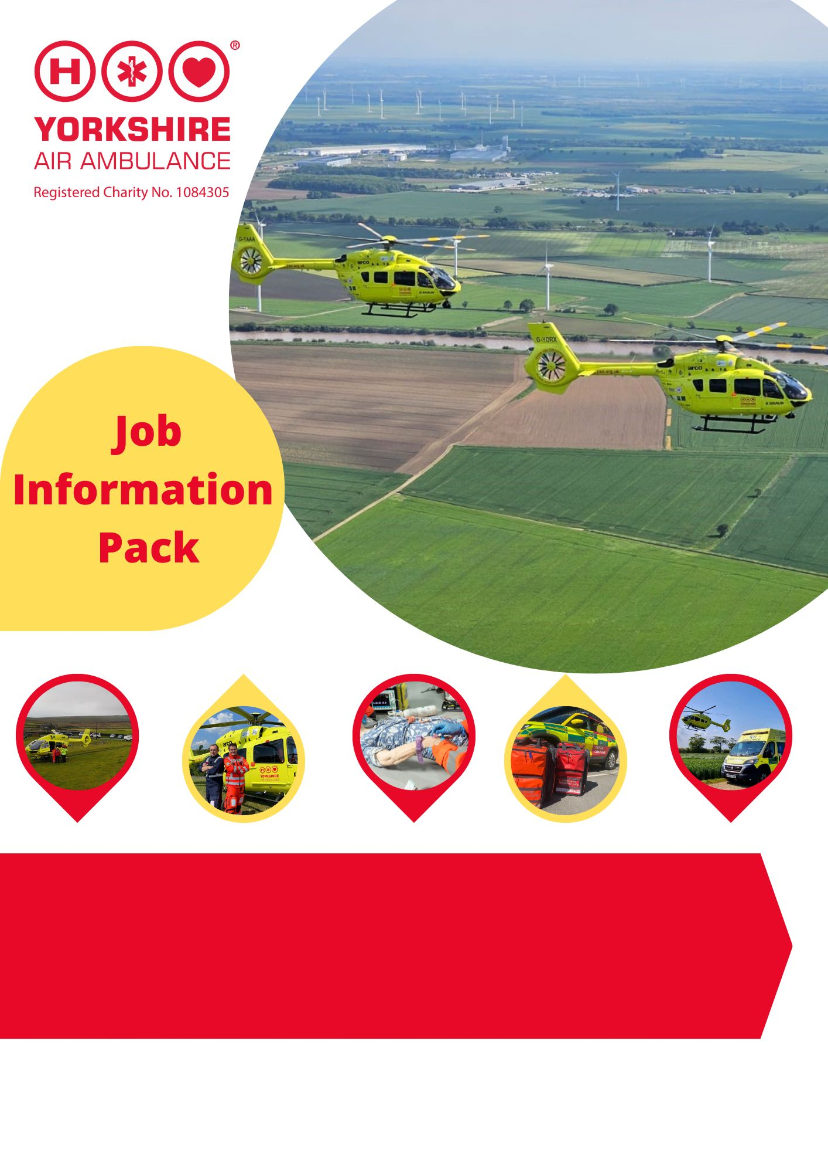

South Community Fundraiser &
West Community Fundraiser

- Full-time flexible position, regular evening and weekend work required.
- Home based, with regular travel for face to face fundraising and meetings.

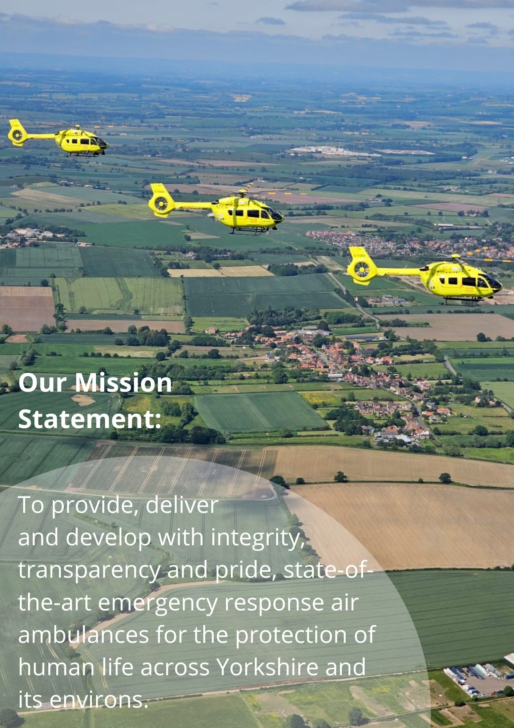

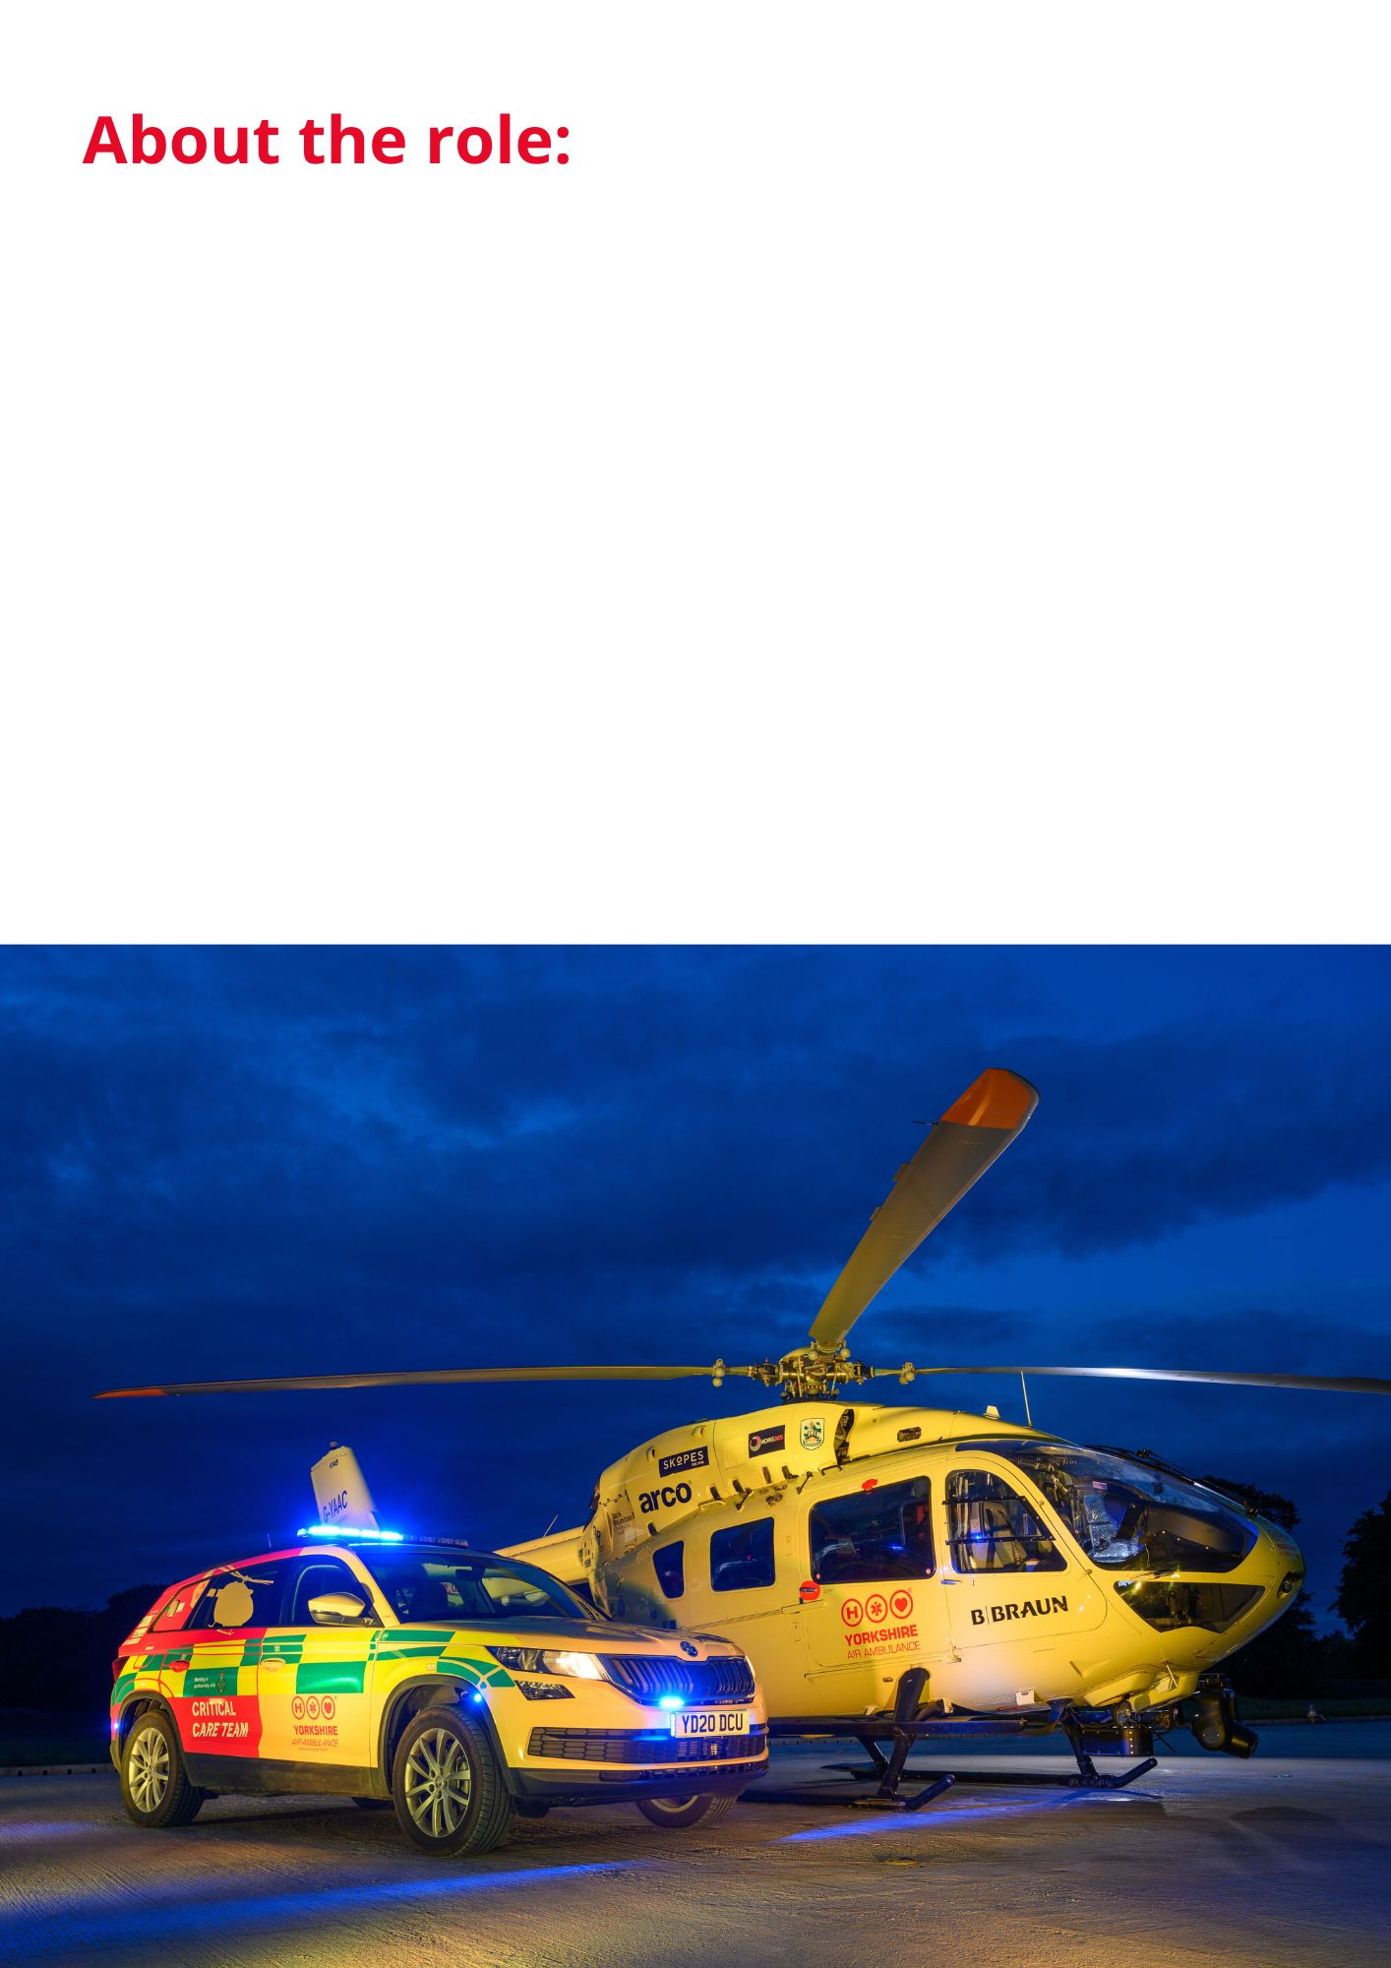
Do you want to feel as though you are helping to save lives every day? When working for YAA as a Community Fundraiser that is exactly what you will be doing!
This is an exciting opportunity for a passionate and motivated individual to become a Community Fundraiser for Yorkshire Air Ambulance. No two days are the same in this varied role, where you will build relationships, inspire supporters, and encourage communities to raise vital funds that help keep our life-saving service flying.
Working from home, you will spend approximately 40% of your time on administration, planning activities, maintaining supporter relationships, and managing fundraising opportunities. The remaining 60% of your week will be spent out in the community attending events, meeting supporters, delivering presentations, and inspiring people to get involved with Yorkshire Air Ambulance. The role involves regular lone working, with the confidence and ability to independently attend events, represent the charity professionally, and build strong relationships with supporters across your region.
Compassion and empathy are essential, as you will often meet former patients and their families whose lives have been impacted by our service. A small manual van is provided for work-related travel, along with all the equipment needed to carry out the role effectively. This is a rewarding opportunity to make a genuine difference every day while helping Yorkshire Air Ambulance continue saving lives across the region.
If you would like to be part of this high-profile, successful regional Charity and think that your skills and experience fit the bill for this exciting role… we look forward to hearing from you!

JOB TITLE | 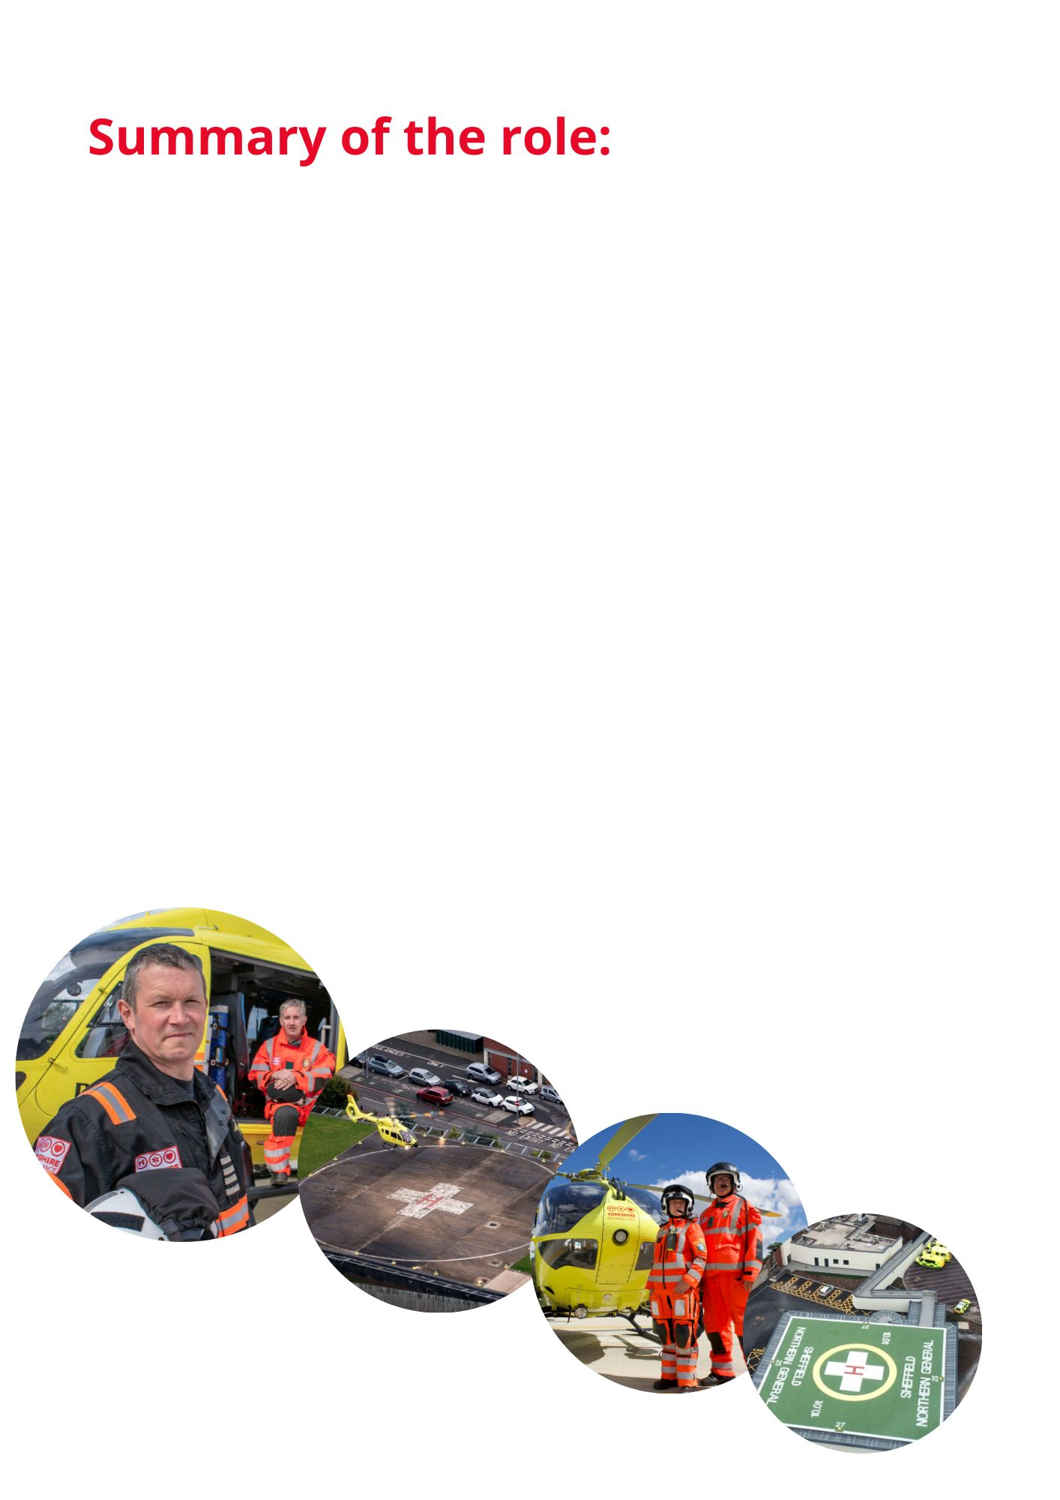  South Community Fundraiser/ West Community Fundraiser
LOCATION | Home based, hybrid position (travelling primarily in the South or West region of Yorkshire)
REPORTING TO | Regional Fundraiser
HOURS | Full Time, permanent contract, flexible as frequent evening and weekend work required.
ADDITIONAL INFO | Requirement to work unsocial hours, evenings and weekends. Time off in Lieu will be given as agreed with Regional Fundraiser.  A small manual van is provided with this role to be kept at home, for work related activity with all work-related travel costs covered.  Expenses can be claimed for work related additional costs as agreed with Regional Fundraiser.  Manual handling will be required of up to 30kg.
JOB PURPOSE | Working closely within the Regional Team, manage and fully participate in the fundraising activity across the region, to ensure the annual financial income & expenditure targets are achieved in order to ensure the life-saving air ambulances are available to the people of Yorkshire.  To ensure all supporters have a great experience and feel fully supported and engaged when raising funds for the charity in line with the charity’s principles and values.  To support established volunteers and recruit new volunteers within the region when necessary.
SALARY | Starting salary of £26,288 p.a

KEY RESPONSIBILITIES AND DUTIES:
- To work with the Regional Fundraiser and Regional Fundraising Manager- West & South to deliver the Community Fundraising Strategy, contributing to achieve the region’s income and expenditure budgets.

- To contribute to the Charity’s Growth Fundraising Strategy including promoting the ‘Saving Lives’ Lotto and other new initiatives.

- To act as the first point of contact for community events, supporters and potential volunteers responding to all enquiries that have come into the office.

- To assist in managing the region’s events diary. Organise, manage and attend community events/functions and ensure appropriate fundraiser or volunteer attendance as required.

- Working with the team to manage the region’s stock and fundraising resources, including stock checking, ordering merchandise and equipment and collecting from the charity’s head office in Elland.

- To act as an ambassador of the Yorkshire Air Ambulance by raising awareness on a daily basis. This could be through public speaking engagements, attending cheque presentations, and representing the Charity at community fundraising events throughout the region.

- To take responsibility for handling, counting and banking cash raised at fundraising events in line with the charity’s cash handling policy.

- Working in partnership with Communications & Marketing team to promote and thank fundraising activity within the region in line with the charity policy. Actively using and updating the Regional Social Media pages as appropriate.

- To utilise the CRM system (supporter and financial recording system) to effectively steward our supporters and follow up all events. Ensuring all funds from notified events are received and recorded correctly and that supporters are suitably thanked.

- To recruit, induct and manage the volunteers and ensure they comply with the Charity’s policies and procedures.

- Comply with the charity’s policies and processes including Financial, Health & Safety (including carrying out risk assessments), GDPR, data protection and ensure effective governance.

- To drive and set up the charity’s Mobile Education Unit as required, full training will be provided.

- To plan for and attend regional meetings/planning meetings/volunteer meetings.

- To undertake other duties and training as may reasonably be required from time to time.

- To be on the on call Rota for West and South volunteers. (1 in 6 weekends).
KNOWLEDGE & SKILLS REQUIRED:
Essential:
- Previous experience in customer service, sales or an income generating role.

- Experience of developing and maintaining long term customer/supporter relationships.

- A willingness to travel and work unsocial hours both in the evenings and at weekends.

- Computer literacy (Microsoft Office Outlook/Word/Excel/PowerPoint).

- Have suitable home-based accommodation to provide a satisfactory working environment.

- Clean full manual driving license and access to own car although a charity vehicle is provided for work mileage.

Desirable:
- Experience of project/event management.

- Experience in a fundraising role.

- Experience of public speaking in front of a variety of groups.

- Residing within the South/West region.

- Experience of working from home.

- Experience of working to an income/expenditure target.

SKILLS & ABILITIES:
Communicating with Others - Pitches communication at the right level both verbally and in writing and checks for understanding. Good listening skills. Uses information to influence others. Able to give tough messages when required.
Building Relationships - Works well with others. Co-operates willingly with others. Able to quickly build effective relationships with all levels both internally and externally and meet the needs of the individual. Treats others with dignity and respect and able to gain the trust of others. Builds strong relationships with others.
Generating Ideas - Continually seeking to improve the service offered by the team by coming up with improved systems and processes and added value activities. Considers pros and cons and impact on team and resources.
Planning for the Future - Plans to achieve their objectives within timescale, balancing short- and long-term requirements. Identifies opportunities and barriers and considers the implications of actions.
Flexibility and Adaptability - Adopts a flexible and adaptable approach. Recovers well from setbacks and resistance from others. Remains calm under pressure and focused on the task. Encourages others to do the same.
Making Decisions - Anticipates issues and takes action to address underlying cause. Reaches effective decisions by gathering and analysing relevant information balancing cost, benefit, and risk implications. Considers options, weighs up pros and cons before deciding on action.
Delivering Results - Accepts accountability and ownership. Ensures self and team delivers on time and to required standard. Has high standards and leads by examples. A good role model. Creates enthusiasm in others.
Self-Motivated - Works well on their own or as part of a team. Demonstrates a positive attitude. Energetic and enthusiastic.

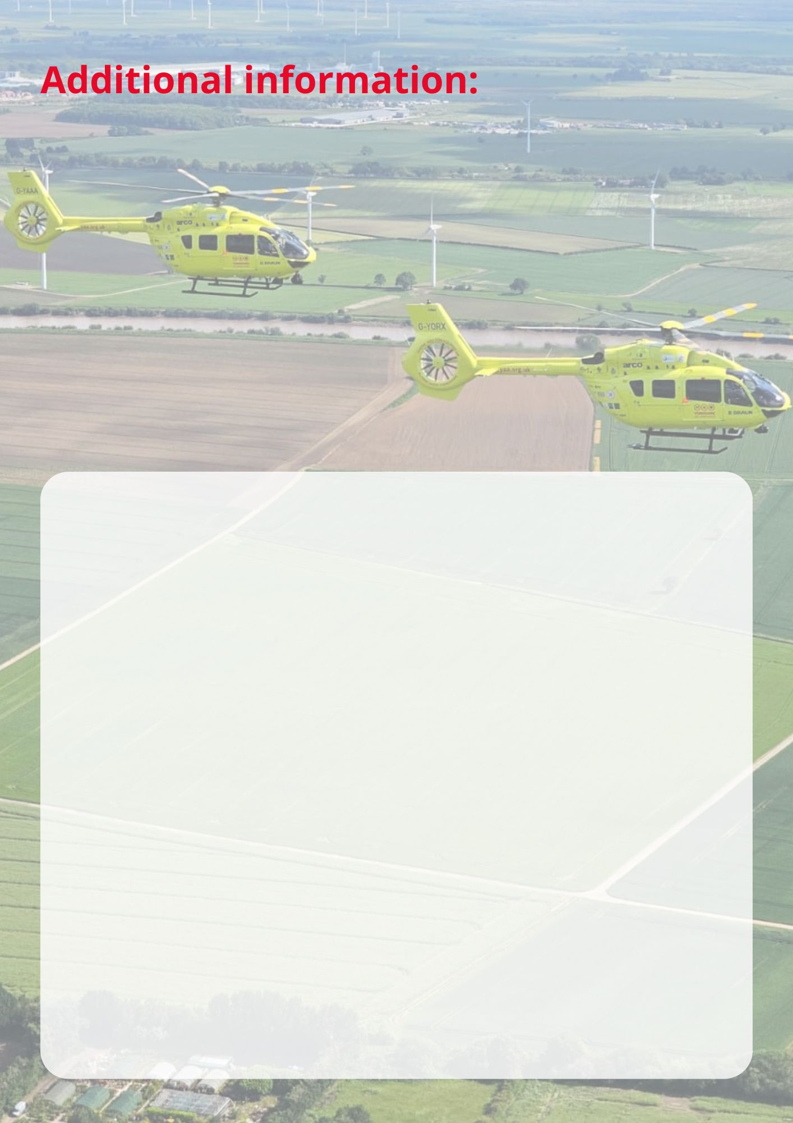

- Starting salary £26,288 p.a.

- Full-time flexible position.

- Discretionary annual staff bonus scheme based on the Charity’s financial performance.

- 25 days paid holiday per annum plus statutory Bank Holidays (pro-rata).

- Time off in lieu for evening and weekend work, where applicable.

- Work Life/Family Balance - a commitment to helping you achieve a work life balance including flexible working opportunities (role dependent), enhanced family leave packages, including maternity, paternity, and adoption/surrogacy.

- Regular team building and away days with a calendar of events and social activities.

- Commitment to training and personal development for all staff, including access to short online training sessions.

- Contributory pension scheme (contributions matched by the Charity up to 8% and annual pensions advice).

- Life assurance plus access to an Employee Assistance Programme covering Financial, Mental and Physical Wellbeing.

- You will be provided with: Uniform, laptop, phone, small manual van and other items required for you to perform your role effectively.

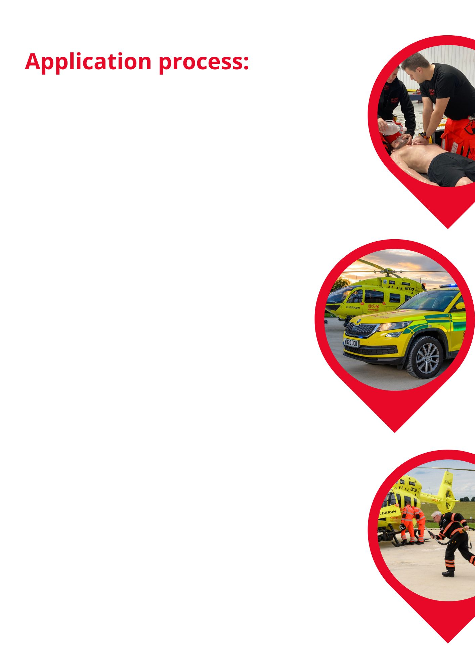

To apply for this position via our website:

- Provide a CV and covering letter stating how your experience, knowledge, abilities and skills match the job requirements along with why you are applying.
- Complete the optional Equal Opportunities Monitoring Form.

For other recruitment queries, please contact
recruitment@yaa.org.uk.

The closing date for this vacancy is 5pm Sunday 4th October 2026.

Interviews will take place on Monday 12th and Tuesday 13th October 2026 at our Nostell Air Support Unit.

If you wish to discuss the job role in more detail, please contact Donna Merrills, South Regional Fundraiser, 07353 114750
Angela Vyas, West Regional Fundraiser, 07471 038522.

Other things to note:

We reserve the right to close the vacancy early if required and would encourage applicants to send in their applications as soon as possible rather than waiting for the closing date.

We encourage applications from all backgrounds and groups – we value equality, diversity and inclusion in all our employment practices, including recruitment, selection and induction. If you require any documents in another format or adjustments to any part of the recruitment & selection process, please do let us know.

The use of AI (Artificial Intelligence) is monitored.

GDPR & our Recruitment Privacy Statement:
The Yorkshire Air Ambulance complies by law with the Data Protection Act 2018 and the EU General Data Protection Regulation. This advises you of how the Charity collects and processes your personal data. The Privacy Statement also declares how the Charity will comply with GDPR and the Data Protection Act 2018. Please ensure you download and read the Statement on our website before completing and submitting your application for employment.

