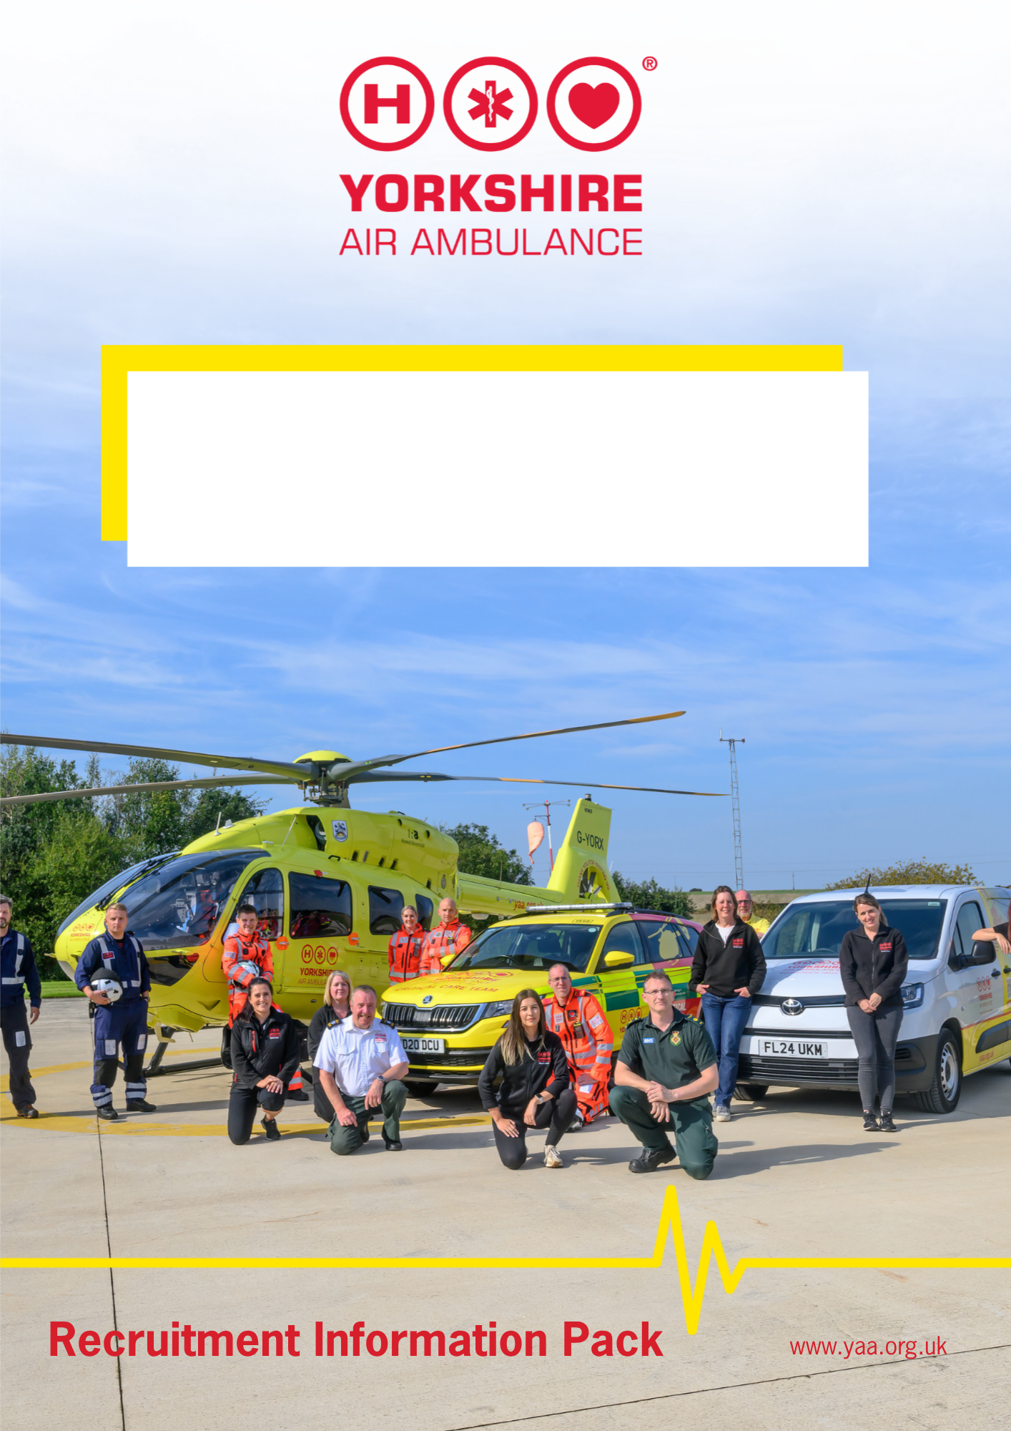

Helicopter Emergency Medical Services (HEMS) Doctor
2026 Recruitment

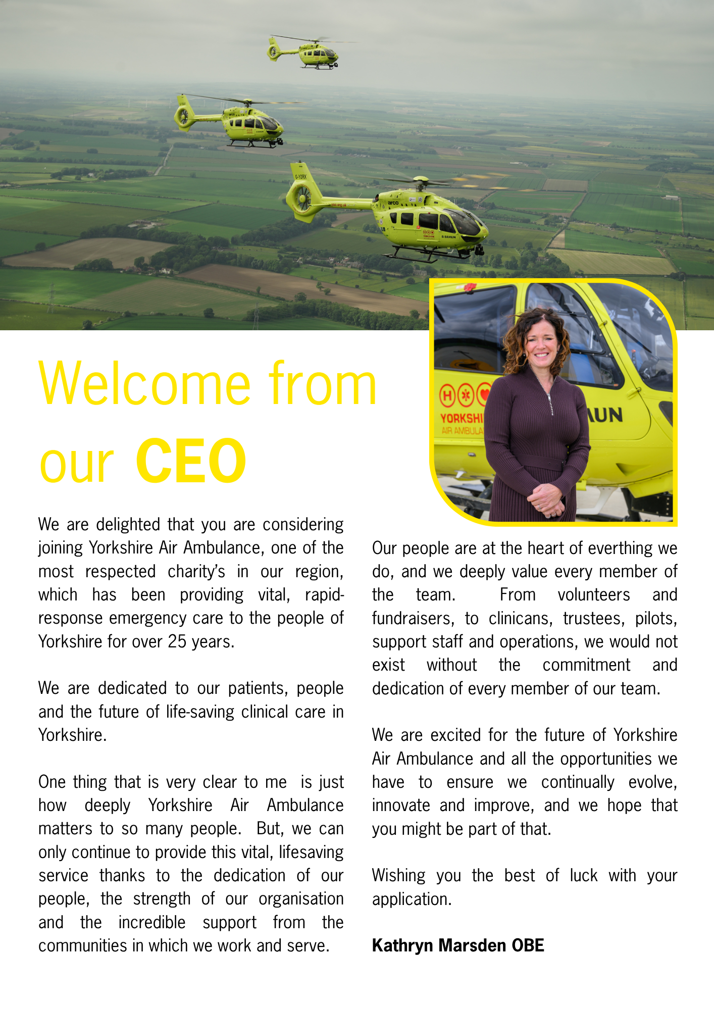

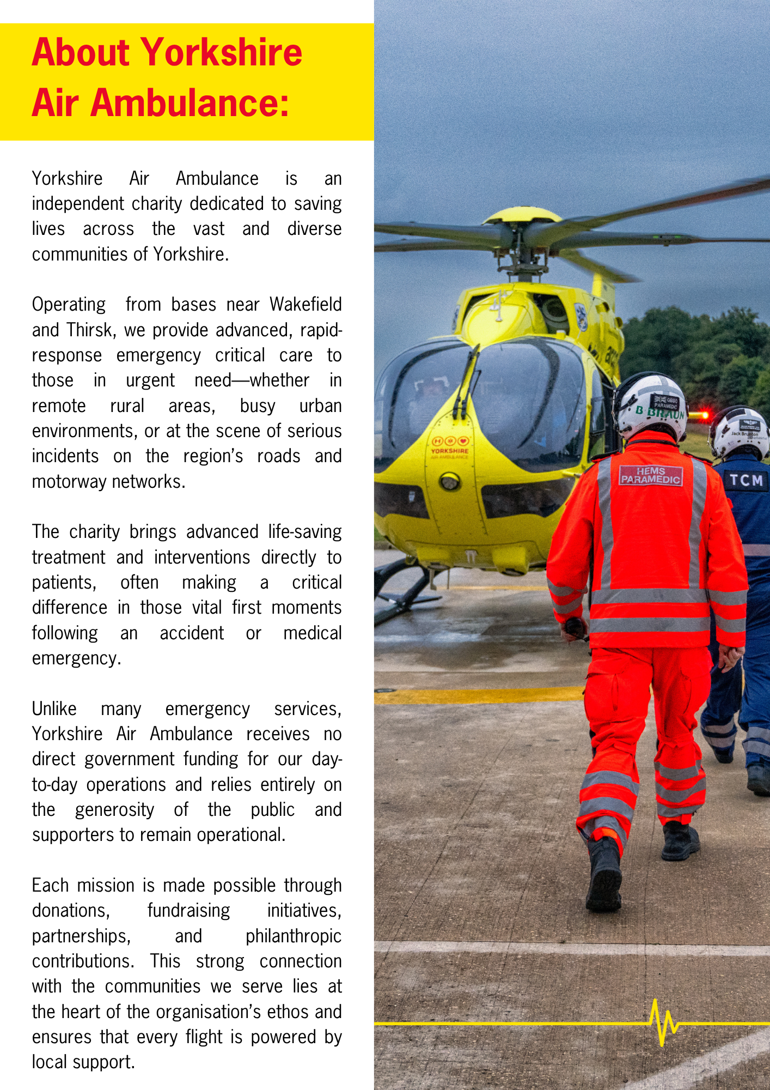

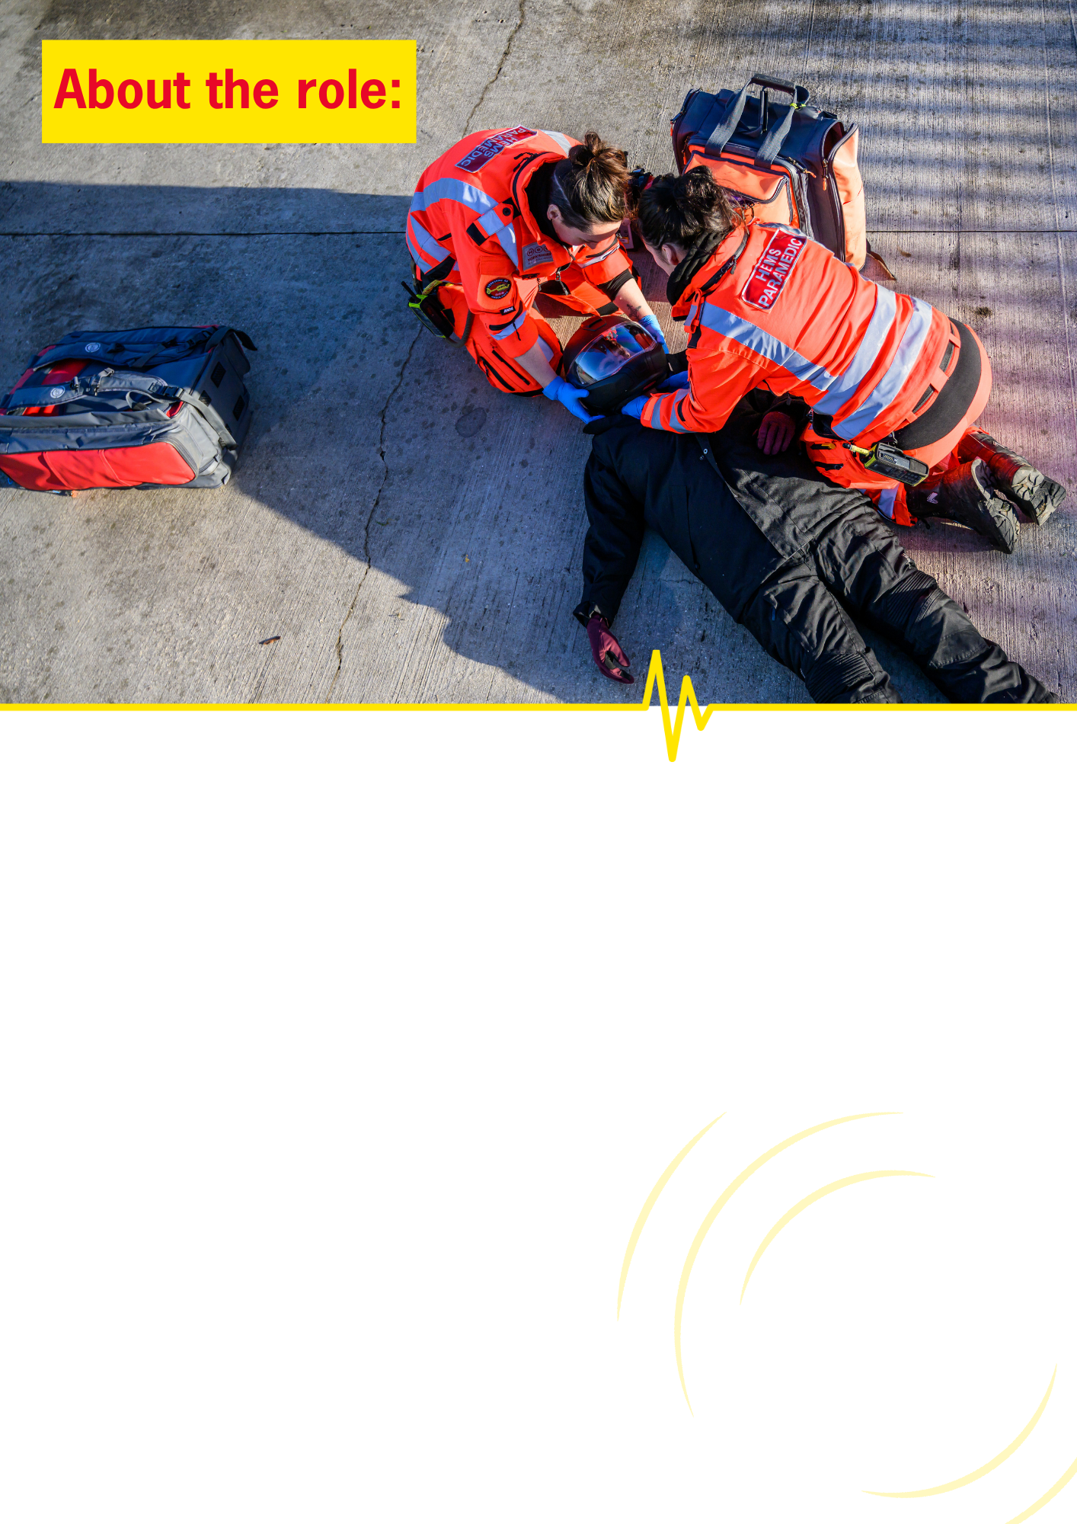

Yorkshire Air Ambulance is looking for ten highly motivated doctors with excellent technical and non-technical skills to join its existing group of consultant level HEMS doctors as part of the next phase of stepwise expansion in doctor-paramedic teams for the provision of pre-hospital critical care for the people of Yorkshire.
Successful applicants will join Yorkshire Air Ambulance (YAA) Medical Director Stuart Reid, YAA Chief Executive Kathryn Marsden, Yorkshire Ambulance Service (YAS) paramedics and the wider YAA team both in providing expert clinical care across helicopter and rapid response car platforms, but also to play an important role in service development in a range of areas with the aim of ensuring the best possible outcomes for our patients.
According to skillset, applicants may have the opportunity to fulfil a number of leadership, service development and quality improvement roles for YAA, become part of clinical on call rota for remote advice and form part of a group of clinical supervisors supporting a programme of doctor training in the future.
The current YAA consultant group is under-represented by female colleagues and those from ethnic minorities and applications from these groups are strongly encouraged.
The posts will be funded by the YAA and hosted by YAS, who currently provide clinical governance oversight and overarching clinical responsibility for YAA clinical operations.

JOB TITLE | Helicopter Emergency Medical Services (HEMS) Doctor
LOCATION | Shifts initially to be primarily delivered at Nostell Air Support Unit, but opportunities for regular working from the Skipton Bridge Air Support Unit may also be possible.  As our stepwise expansion in clinical services continues, applicants will be required to work across both bases in the future.
REPORTING TO | YAA Medical Director
HOURS | Part time, 2.5 programmed activities per week.
ADDITIONAL INFO | Requirement to work unsocial hours, evenings/lates and weekends, to support a move to Doctor-Paramedic shifts 0700-0130 7 days a week by April 2027.
JOB PURPOSE | As part of the YAA clinical team, to deliver pre-hospital critical care of the highest quality to the people of Yorkshire and its environs.
SALARY | Programmed activities payable as per NHS consultant contract pay scale.
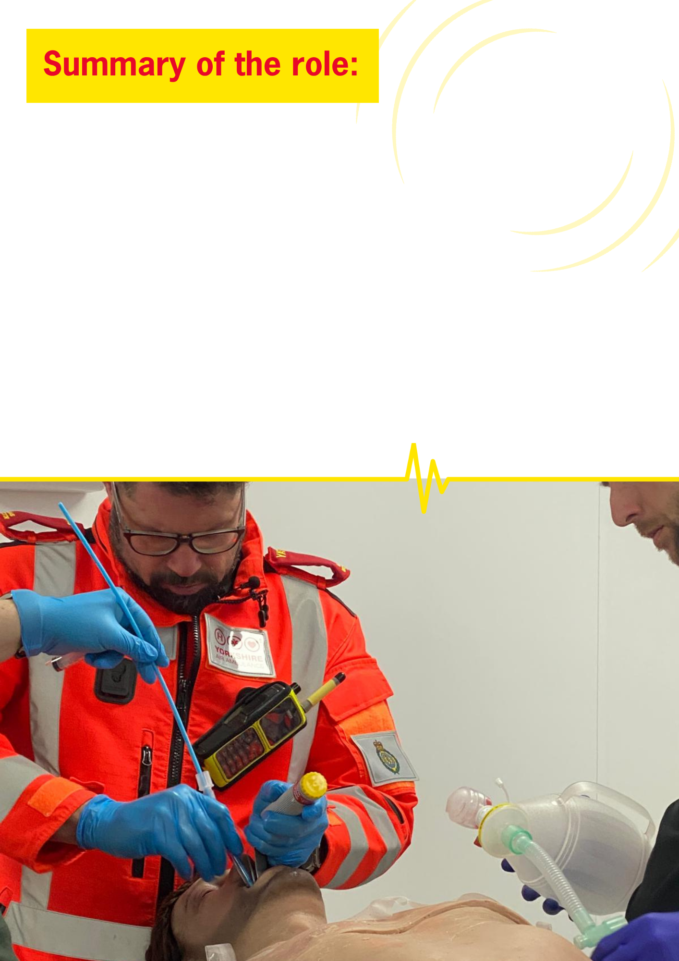


- To undertake a period of mandatory induction probation; demonstrating completion of all aspects of HEMS clinical training and successful completion of the YAA personal fitness assessment and summative sign off by a member of the YAA Clinical Leadership Team prior to beginning unsupervised clinical shifts.
- To deliver a high standard of pre-hospital emergency care across a full range of trauma and medical presentations in a mixed urban / rural operational area, to include the provision of pre-hospital emergency anaesthesia and resuscitative thoracotomy.
- Working seamlessly as one clinical unit with the YAA paramedic team, pilots and technical crew members, and to positively contribute to their education and development.
- Working closely on scene with colleagues from Yorkshire Ambulance Service and other emergency services.
- To provide evidence based care and best practice, in line with YAA standard operating procedures and guidelines.
- To comprehensively and accurately document all jobs and contribute to routine audit of cases and outcomes.
- To work closely with the YAA medical director, YAA Clinical Governance Lead and YAA Clinical Operations Manager and their respective teams.
- To fully engage in all aspects of clinical governance and help foster a safe, open, transparent culture where colleagues feel able to raise concerns for discussion.
- Routine duties on base including drug management, aircraft and medical equipment checks.
- Whilst working for YAA, to act as an ambassador, recognising that every interaction presents an opportunity to support fundraising and raise awareness of the charity’s work. YAA clinical staff are required to demonstrate this ambassadorial role consistently throughout the year, including appearances within media and social media ensuring they represent YAA in a professional, informed, and engaging manner.
- To provide expert input to clinical developments with the opportunity to take a leadership role in areas of interest.
- To contribute to a “top cover” rota for remote clinical advice and support - dependent on experience, this will be subject to additional competitive selection post initial probationary period of no less than 3 months.
- To work at all times according to Yorkshire Ambulance Service and Yorkshire Air Ambulance organisational values.
- To undertake other duties and training as may reasonably be required from time to time.


Essential:
- Full GMC registration with licence to practice and up to date appraisal / revalidation.
- Substantive Consultant or having accepted an Advisory Appointments Committee (AAC) approved substantive post in Anaesthetics/ EM/ ICM
- Diploma in Immediate Medical Care (DipIMC)
- Completion of PHEM training post OR completion of full time HEMS fellow post leading to sign off for independent practice OR equivalent training
- Evidence of formal training in anaesthesia to include RCOA initial competencies and rapid sequence induction
- Evidence of ongoing experience in pre-hospital emergency anaesthesia.
- Demonstrable engagement in clinical governance processes
- Demonstrable ability to work within a multi-disciplinary team
- Demonstrable ability to work under pressure
- Exemplary communication skills
- Ability to successfully complete a fitness test
- Evidence of previous / ongoing qualification in ALS / ATLS – ETC / APLS or equivalent
- Evidence of ongoing CPD relevant to HEMS practice
- Demonstrable enthusiasm for evidence based medicine and applying research to clinical practice
- Good IT, data management and interpretation skills
- Professional indemnity insurance
- Ability to travel to both YAA airbases, YAA charity HQ in Elland and throughout the region
- Willingness to participate in an annual 1:1 with YAA Medical Director
- Agreement from head of service at base trust to undertake the post if appointed
- Ability to engage flexibly in a period of induction

Desirable:
- Fellowship in Immediate Medical Care (FIMC)
- Significant PHEM experience beyond PHEM training or HEMS fellow post
- Experience and knowledge of pre-hospital care systems in Yorkshire
- Current experience of delivering major trauma care within a Major Trauma Centre
- Level 1/RCEM Core equivalent qualification in point of care ultrasound
- Leadership role in pre hospital care, clinical governance, resuscitation or major trauma related area
- Experience in major incident or mass casualty incident – preparedness or clinically
- Life support course instructor
- Role in Postgraduate Medical Education eg College Tutor, TPD
- Higher Degree (MD/MSc) in allied subject: (Resuscitation /Trauma Sciences)
- Postgraduate research portfolio/Senior Lecturer post
- Evidence of audit and/or quality improvement activity
- Experience in delivering remote advice in a pre-hospital or emergency setting
- Trained appraiser
- Involvement in a clinical trial eg site principle investigator


Planning for the Future - Plans to achieve their objectives within timescale, balancing short- and long-term requirements. Identifies opportunities and barriers and considers the implications of actions.
Communicating with Others - Pitches communication at the right level both verbally and in writing and checks for understanding. Good listening skills. Uses information to influence others. Able to give tough messages when required.
Generating Ideas - Continually seeking to improve the service offered by the team by coming up with improved systems and processes and added value activities. Considers pros and cons and impact on team and resources.
Building Relationships - Works well with others. Co-operates willingly with others. Able to quickly build effective relationships with all levels both internally and externally and meet the needs of the individual. Treats others with dignity and respect and able to gain the trust of others. Builds strong relationships with others.
Flexibility and Adaptability - Adopts a flexible and adaptable approach. Recovers well from setbacks and resistance from others. Remains calm under pressure and focused on the task. Encourages others to do the same.
Making Decisions - Anticipates issues and takes action to address underlying cause. Reaches effective decisions by gathering and analysing relevant information balancing cost, benefit, and risk implications. Considers options, weighs up pros and cons before deciding on action.
Delivering Results - Accepts accountability and ownership. Ensures self and team delivers on time and to required standard. Has high standards and leads by examples. A good role model. Creates enthusiasm in others.
Self-Motivated - Works well on their own or as part of a team. Demonstrates a positive attitude. Energetic and enthusiastic.

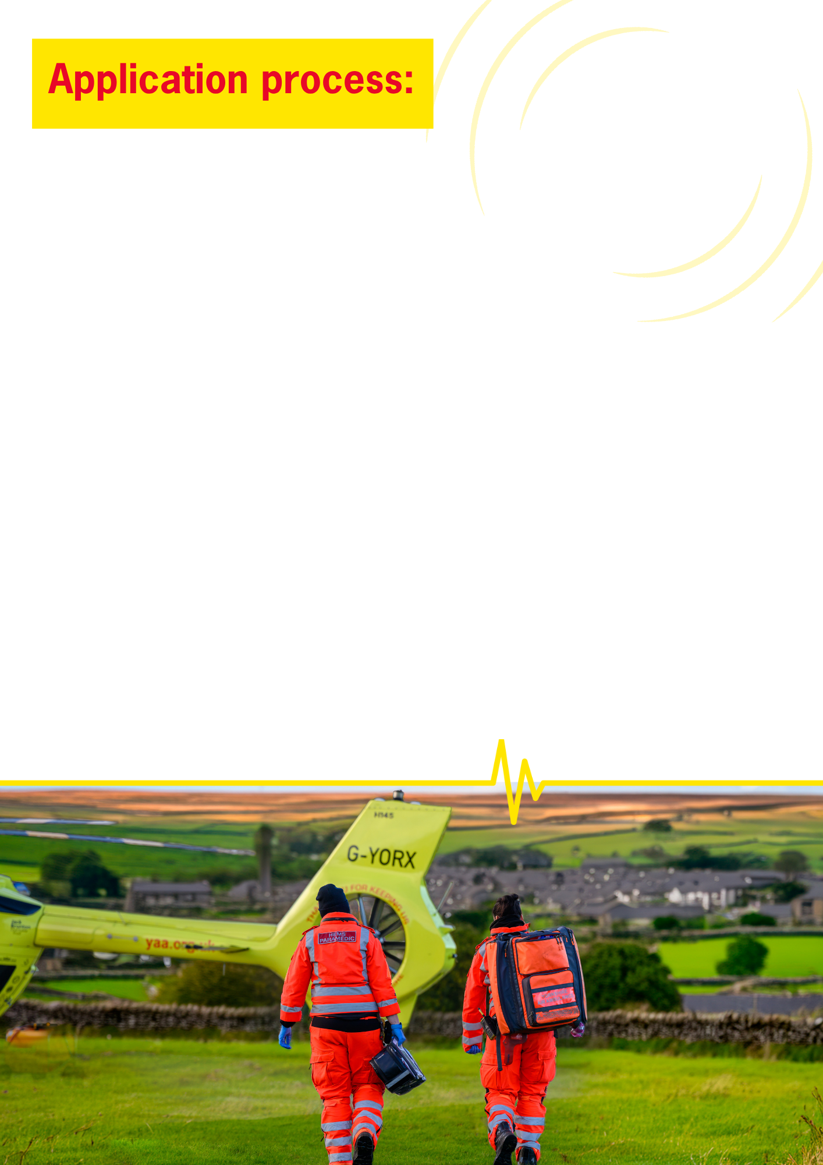
- Applications are via the Trac jobs portal via the link below:
Trac jobs

For other recruitment queries, please contact: recruitment@yaa.org.uk

The closing date for this vacancy is 19/6/26

Interviews are anticipated to take place on 7/7/26 and 9/7/26

If you wish to discuss the job role in more detail, please contact: Dr Stuart Reid, YAA Medical Director via email: stuart.reid6@nhs.net

Other things to note:

We reserve the right to close the vacancy early if required and would encourage applicants to send in their applications as soon as possible rather than waiting for the closing date.

We encourage applications from all backgrounds and groups – we value equality, diversity and inclusion in all our employment practices, including recruitment, selection and induction. If you require any documents in another format or adjustments to any part of the recruitment & selection process, please do let us know.

The use of AI (Artificial Intelligence) is monitored.

GDPR & our Recruitment Privacy Statement:
The Yorkshire Air Ambulance complies by law with the Data Protection Act 2018 and the EU General Data Protection Regulation. This advises you of how the Charity collects and processes your personal data. The Privacy Statement also declares how the Charity will comply with GDPR and the Data Protection Act 2018. Please ensure you download and read the Statement on our website before completing and submitting your application for employment.

