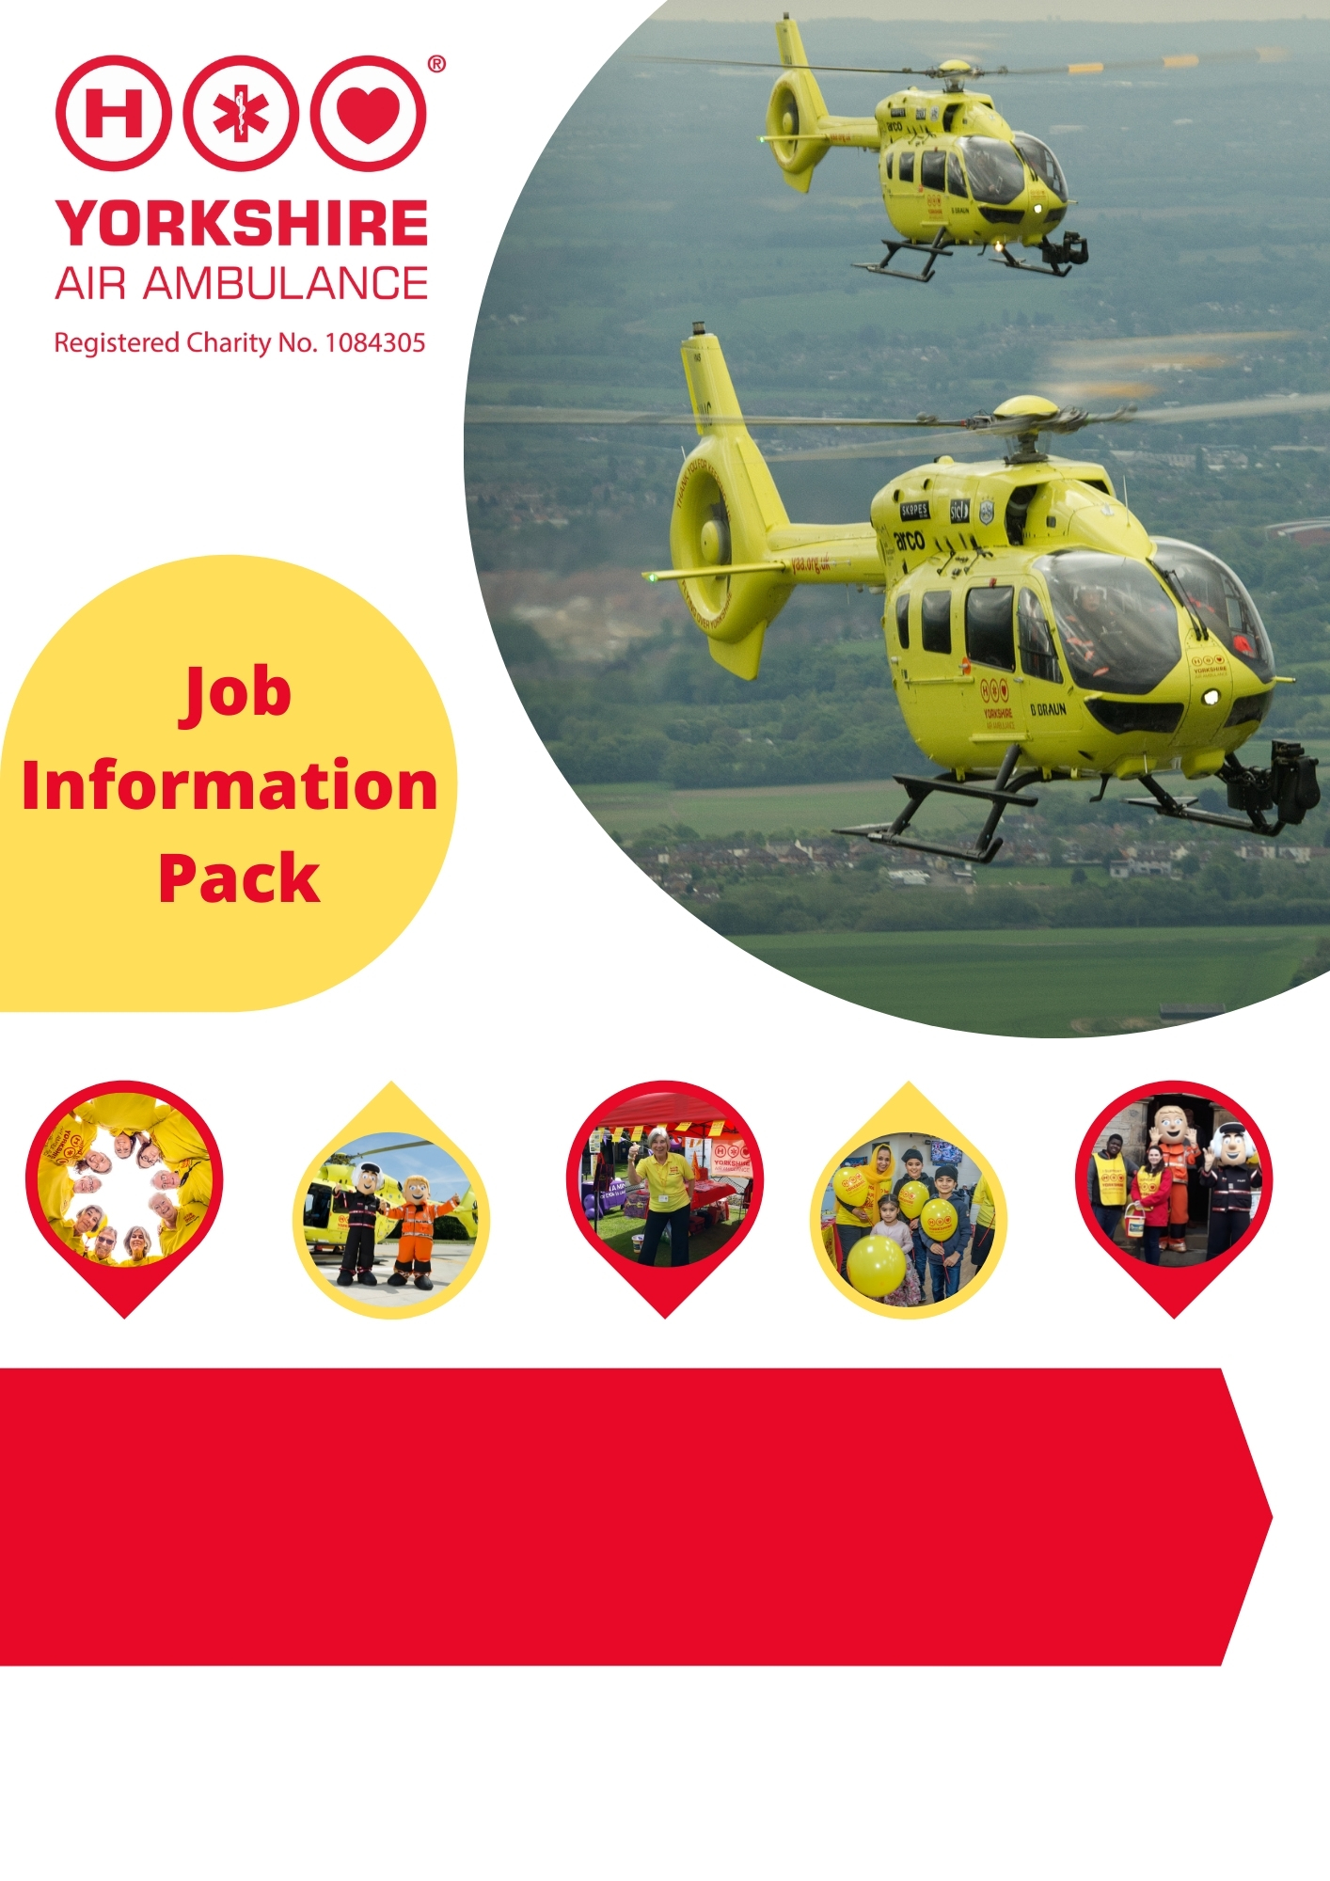

West Region Community Fundraiser

- Full-time flexible position, regular evening and weekend work required.
- Home based, travelling within the West Yorkshire area.

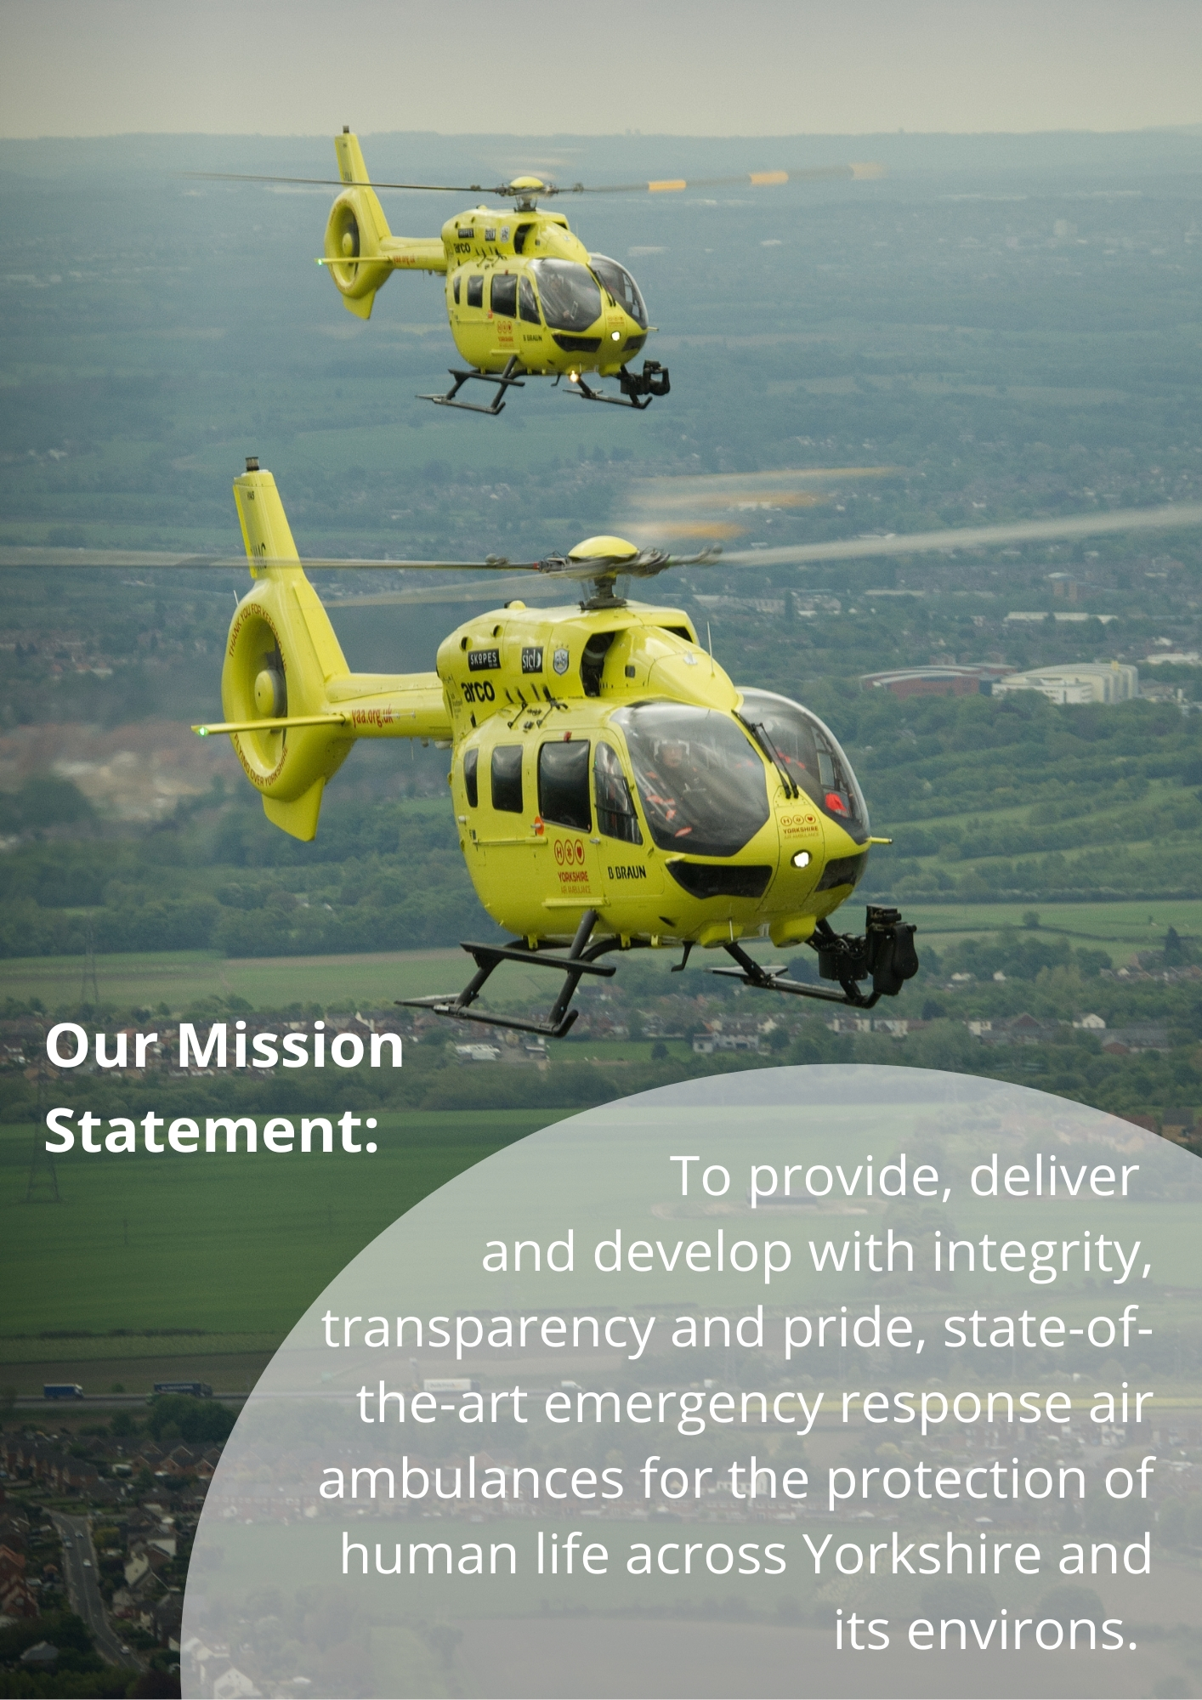

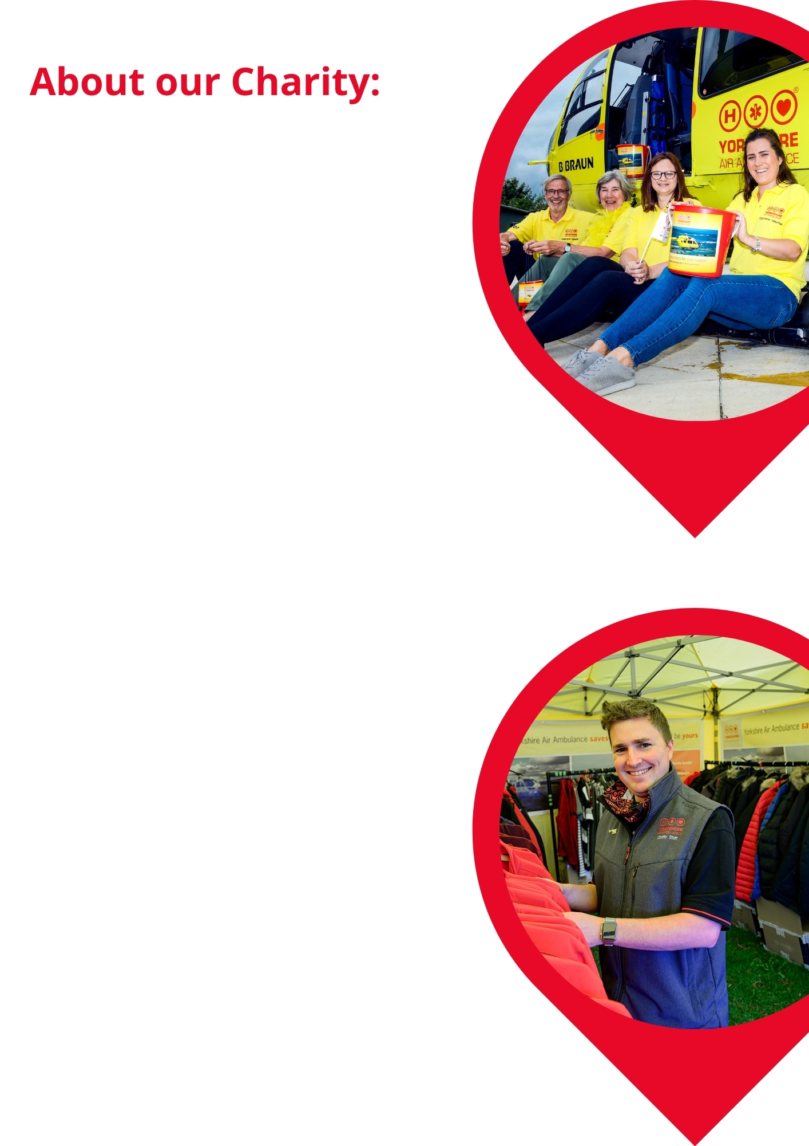
Not everyone realises that the Yorkshire Air Ambulance relies solely on the generosity of individuals and organisations to help save lives across your region. In fact, as an independent Charity we only receive help through secondment of the paramedics from the Yorkshire Ambulance Service NHS Trust. We need to raise £12,000 per day to keep both of Yorkshire’s air ambulances and highly-trained crew in the air. This is the equivalent of £4.4m every single year.

As a rapid response emergency service, our air ambulances serve a population of five million people across four million acres. Our two air ambulances operate from Nostell Priory near Wakefield in West Yorkshire and RAF Topcliffe near Thirsk in North Yorkshire, covering the whole of Yorkshire seven days a week, 365 days per year. Wherever the air ambulance lands at the scene of an accident, it is a maximum of 20 minutes from a Major Trauma Centre for the patient’s injuries or illness.

Our air ambulance helicopters are Airbus H145 models and are widely recognised across Yorkshire. They fly our Critical Care Paramedics and Consultant level Doctors to treat critically ill and injured patients across Yorkshire every day of the week – ultimately taking the treatment to the patient, before the transfer to hospital.

Nearly 8,500 patients’ lives have been changed by the Yorkshire Air Ambulance since the Charity began in October 2000.

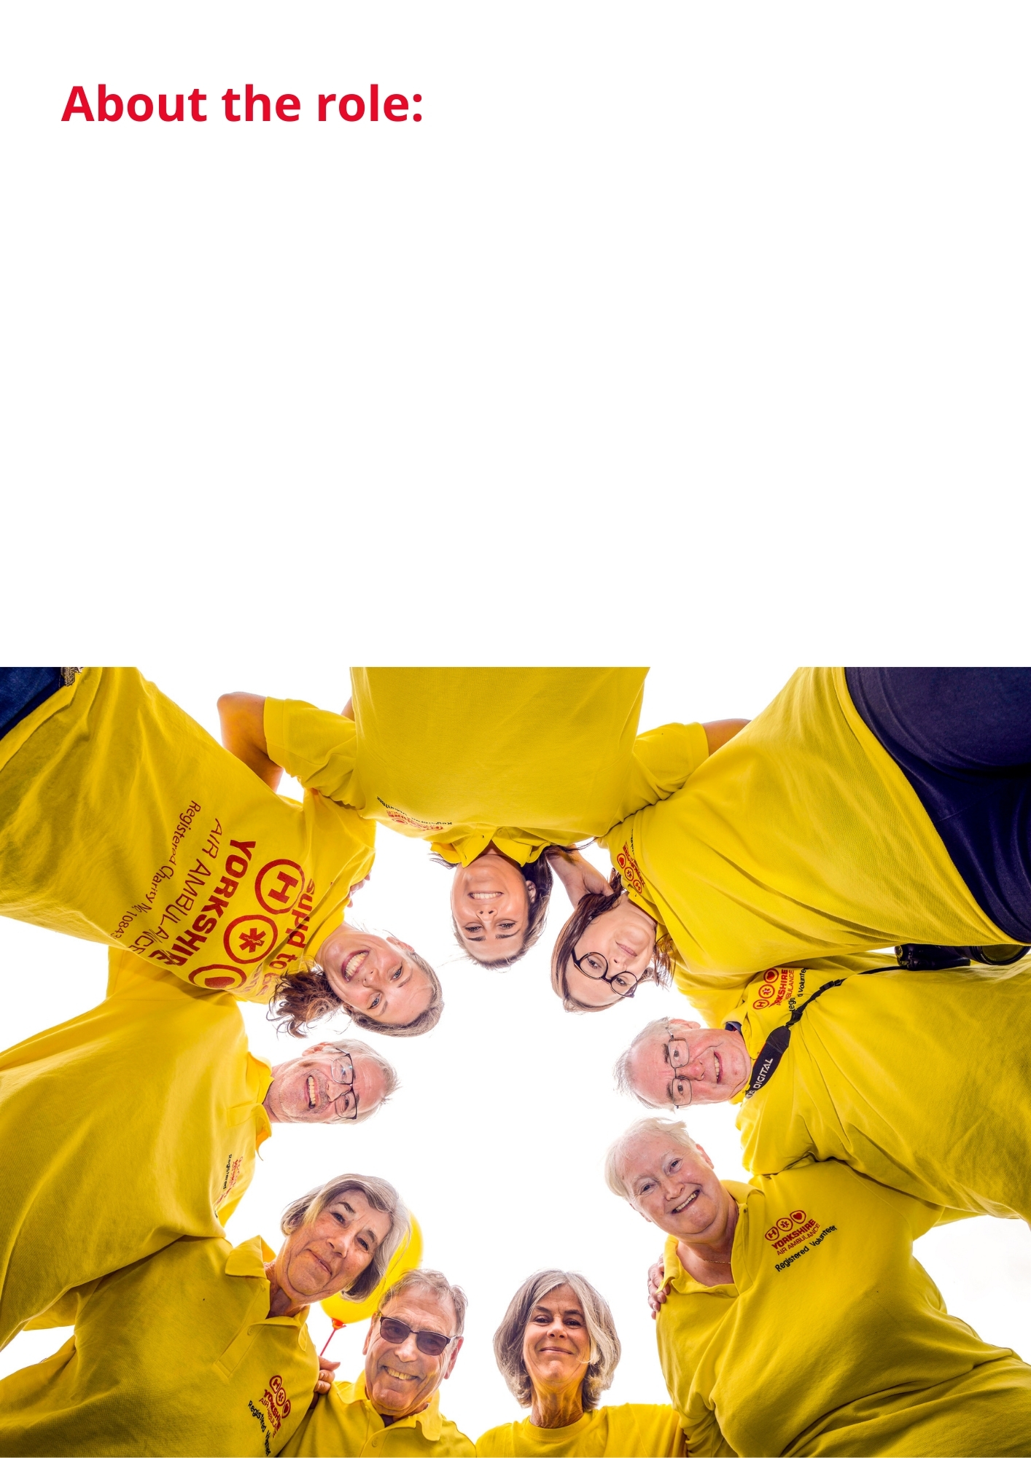

Do you want to feel as though you are helping to save lives every day? When working for YAA as a Community Fundraiser that is exactly what you will be doing! Raising the profile of this amazing charity, you will be active within the designated community at fundraising events and local shows building relationships with our supporters/donors.
We are currently seeking to recruit enthusiastic, professional people able to engage with all members of the public to increase the contributions of individuals and groups through providing support and advice where necessary. You will able to forge new relationships with supporters through raising awareness of the charity’s values aims and goals.
If you would like to be part of this high-profile, successful regional Charity and think that your skills and experience fit the bill for this exciting role… we look forward to hearing from you!

JOB TITLE | Community Fundraiser
LOCATION | Home based, hybrid position (travelling primarily in the West region of Yorkshire, our fundraising regions are on the map below)
REPORTING TO | West Regional Fundraiser
HOURS | Full Time, flexible as frequent evening and weekend work required
ADDITIONAL INFO | Requirement to work unsocial hours, evenings and weekends. Time off in Lieu will be given as agreed with Regional Fundraiser  A small van is provided with this role to be kept at home, for work related activity with all work-related travel costs covered.  Expenses can be claimed for work related additional costs as agreed with Regional Fundraiser.  Some lifting & handling will be required.
JOB PURPOSE | Working closely with the Regional Team, manage and fully participate in the fundraising activity across the region, to ensure the annual financial income & expenditure targets are achieved in order to ensure the life-saving air ambulances are available to the people of Yorkshire.  To ensure all donors have a great experience and feel fully supported and engaged when raising funds for the charity in line with the charity’s principles and values  To support established volunteers and recruit new volunteers within the region when necessary.

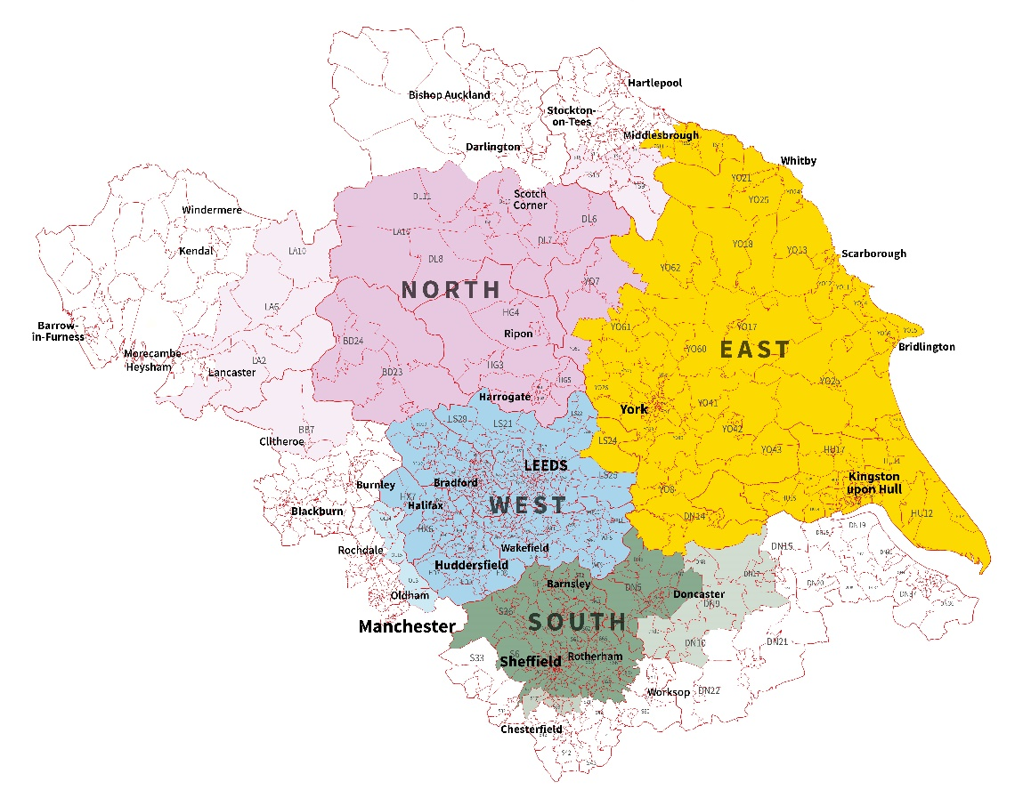

Key Responsibilities and Duties

- To assist in managing the West region’s events diary. Organise, manage and attend community events/functions and ensure appropriate fundraiser or volunteer attendance as required.

- To act as the first point of contact for fundraising events and supporters.

- To utilize the CRM system (donor and financial recording system) to effectively manage our donors, maximise income, and follow up all events, ensuring all funds are from notified events are received and recorded correctly and that donors are suitably thanked.

- To act as representative of the Yorkshire Air Ambulance by raising awareness through public speaking engagements, attending cheque presentations, and representing the Charity at community fundraising events throughout the West region.

- To recruit, induct and manage the volunteers and ensure they comply with the Charity’s policies and procedures.

- Working in partnership with Communications & Marketing team promote and thank fundraising activity within the region in line with the charity policy, to maximise income generation within the community

- To take responsibility for handling, counting and banking cash raised at fundraising events.

- Comply with the charity’s policies and processes including Financial, Health & Safety (including carrying out risk assessments) GDPR, data protection and ensure effective governance.

- To demonstrate a willingness to drive the charity’s promotional vehicle as required, full training will be provided.

- Working with the team to manage the region’s stock and fundraising resources.

- To plan for and attend regional meetings/planning meetings/volunteer meetings.

- To undertake other duties and training as may reasonably be required from time to time.

Knowledge and Skills Required:
Essential:
- Previous experience in community fundraising, sales or an income generating role.

- Experience of developing and maintaining long term customer/donor relationships.

- Experience of presenting to a variety of groups.

- A willingness to travel and work unsocial hours both in the evenings and at weekends.

- Computer literacy (Microsoft Office Outlook/Word/Excel/PowerPoint).

- Have suitable home-based accommodation to provide a satisfactory working environment.

- Clean driving license and access to own car although a charity vehicle is provided for work mileage.

Desirable:
- Experience of project/event management.

- Residing within the West region.

- Experience of working from home.

- Experience of working to an income/expenditure target.

Skills and Abilities:
Planning for the Future - Plans to achieve their objectives within timescale, balancing short- and long-term requirements. Identifies opportunities and barriers and considers the implications of actions.
Communicating with Others - Pitches communication at the right level both verbally and in writing and checks for understanding. Good listening skills. Uses information to influence others. Able to give tough messages when required.
Leading a Team - Setting direction for a team and motivating them to deliver results.
Generating Ideas - Continually seeking to improve the service offered by the team by coming up with improved systems and processes and added value activities. Considers pros and cons and impact on team and resources.
Building Relationships - Works well with others. Co-operates willingly with others. Able to quickly build effective relationships with all levels both internally and externally and meet the needs of the individual. Treats others with dignity and respect and able to gain the trust of others. Builds strong relationships with others.
Flexibility and Adaptability - Adopts a flexible and adaptable approach. Recovers well from setbacks and resistance from others. Remains calm under pressure and focused on the task. Encourages others to do the same.
Making Decisions - Anticipates issues and takes action to address underlying cause. Reaches effective decisions by gathering and analysing relevant information balancing cost, benefit, and risk implications. Considers options, weighs up pros and cons before deciding on action.
Delivering Results - Accepts accountability and ownership. Ensures self and team delivers on time and to required standard. Has high standards and leads by examples. A good role model. Creates enthusiasm in others.
Self-Motivated - Works well on their own or as part of a team. Demonstrates a positive attitude. Energetic and enthusiastic.

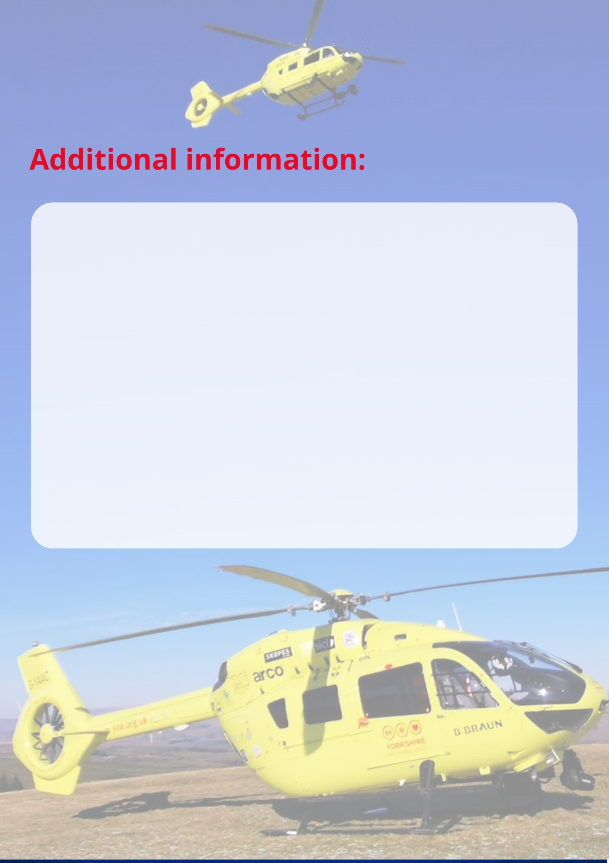

- Starting salary £23,100.

- Discretionary annual staff bonus scheme based on the Charity’s financial performance and personal KPIs.

- 22 days paid holiday per annum plus statutory Bank Holidays (pro-rata). Time off in Lieu for evening and weekend work.

- Company van provided with full travel paid for.

- Work Life/Family Balance - a commitment to helping you achieve a work life balance including flexible working opportunities, enhanced family leave packages, including maternity, paternity, and adoption/surrogacy.

- Regular team building and away days with the Fundraising team and a calendar of events and social activities.

- Commitment to training and personal development for all staff, including access to short online training sessions.

- Eligible to apply for a Blue Light Card, gaining discount at 100’s of businesses.

- Contributory pension scheme (contributions matched by the Charity up to 8% and annual pensions advice).

- Life Assurance plus employee assistance programme covering Financial, Mental and Physical Wellbeing.

Closing date for this role is: Friday 29th April 2022 at 12 noon

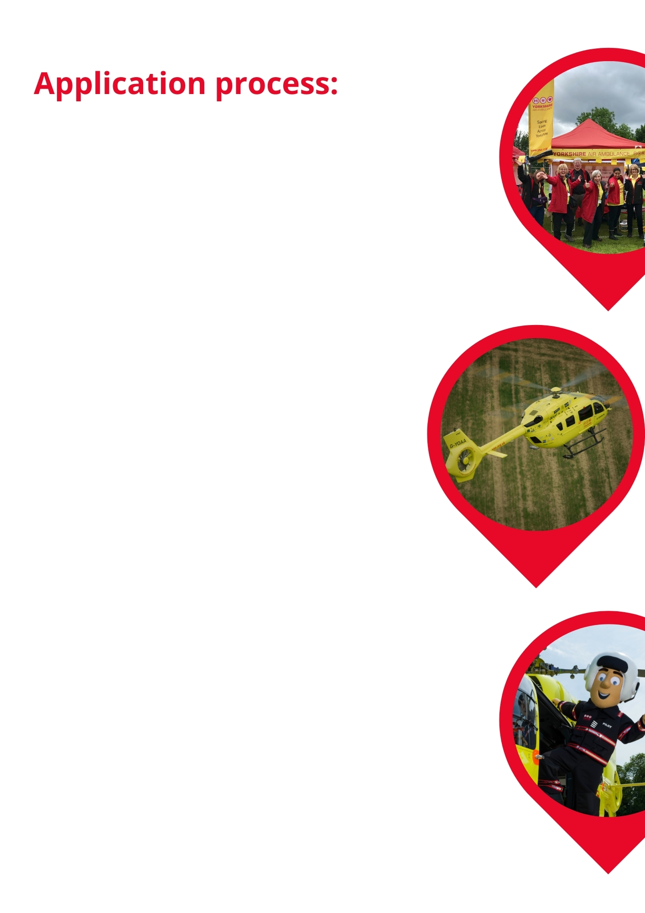

To apply for this position:

- Provide a CV and covering letter stating how you match the knowledge, abilities and skills required and why you are applying.
- Complete the Equal Opportunities form (optional)

Please email CV and covering letter back to us by forwarding it to: recruitment@yaa.org.uk.

If you wish to discuss the job role in more detail,
please contact Helen Berriman on 07385 089007 or
Vickie Bowden on 07876 899097.

GDPR & our Recruitment Privacy Statement:
The Yorkshire Air Ambulance complies by law with the Data Protection Act 2018 and the EU General Data Protection Regulation. This advises you of how the Charity collects and processes your personal data. The Privacy Statement also declares how the Charity will comply with GDPR and the Data Protection Act 2018. Please ensure you download and read the Statement on our website before completing and submitting your application for employment.

