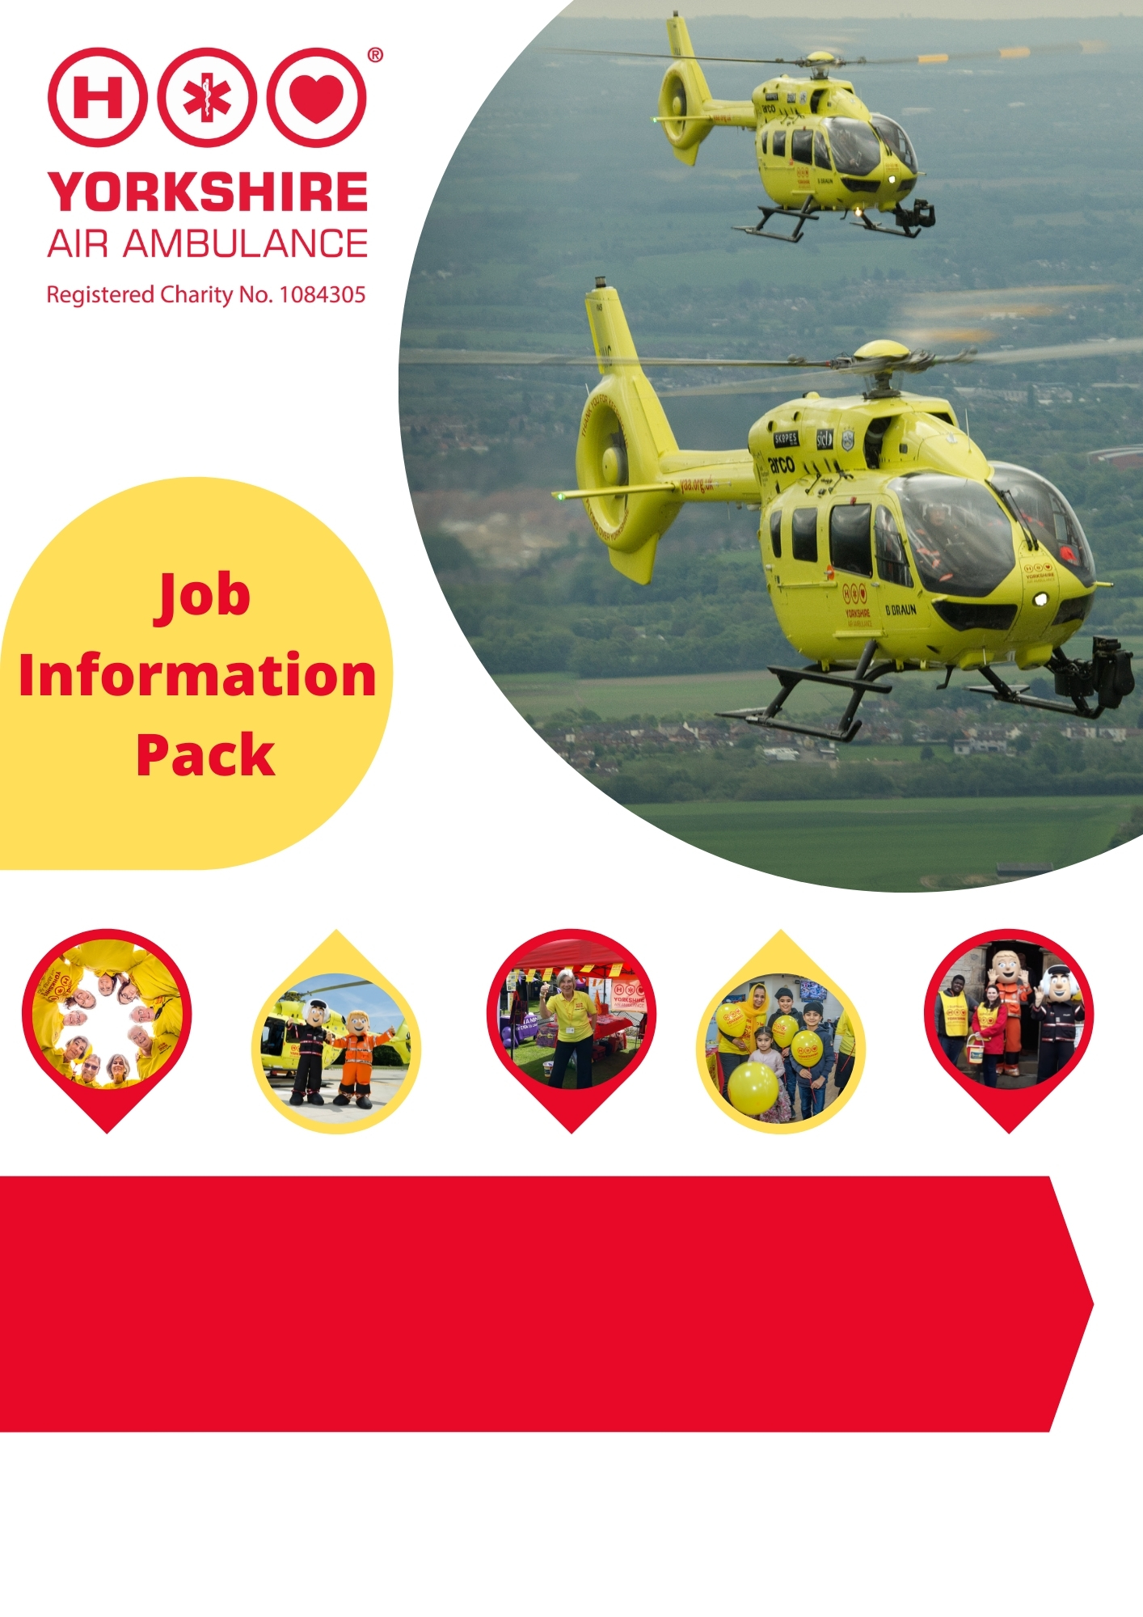

Regional Fundraising Manager – West and South Yorkshire

- Full-time position, some evening and weekend work required.
- Home based, travelling within the West and South Yorkshire areas.

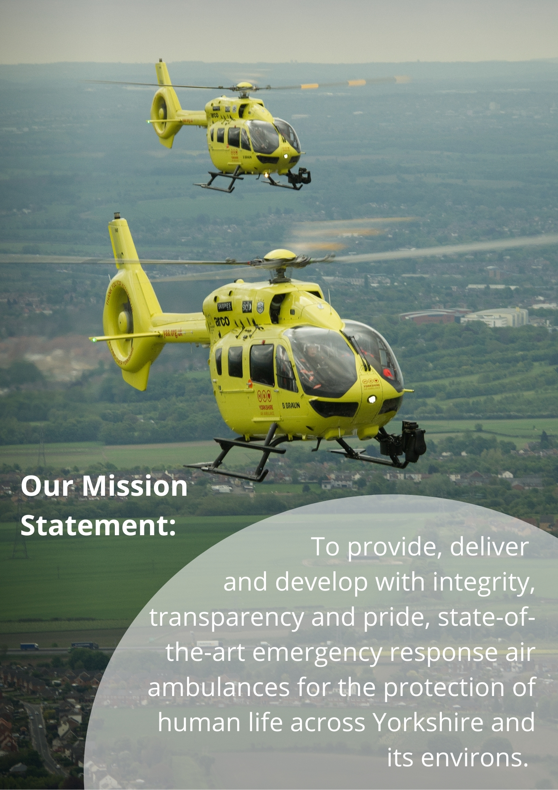

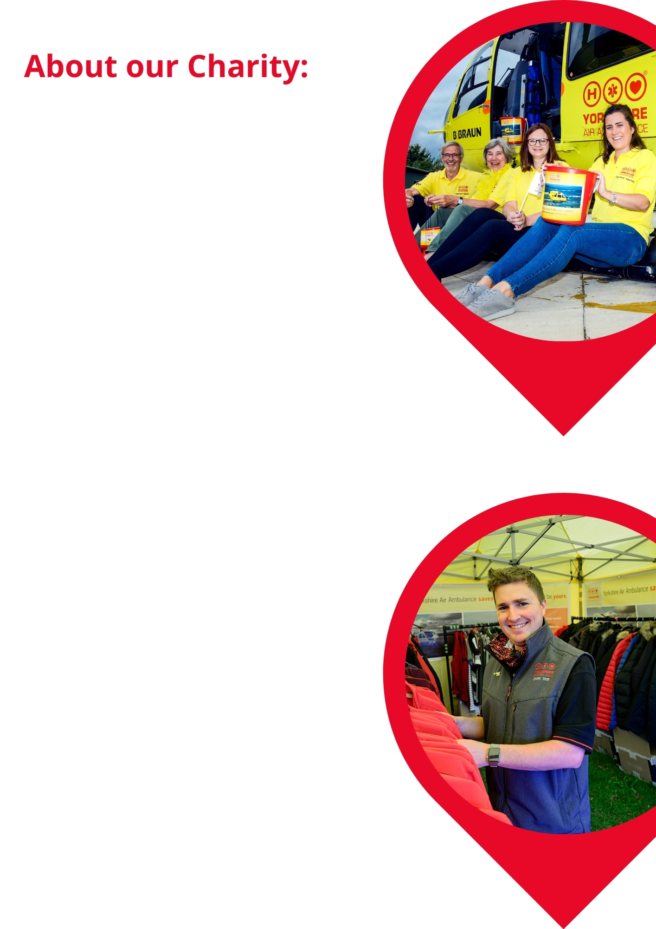
Not everyone realises that the Yorkshire Air Ambulance relies solely on the generosity of individuals and organisations to help save lives across your region. In fact, as an independent Charity we only receive help through secondment of the paramedics from the Yorkshire Ambulance Service NHS Trust. We need to raise £12,000 per day to keep both of Yorkshire’s air ambulances and highly-trained crew in the air. This is the equivalent of £4.4m every single year.

As a rapid response emergency service, our air ambulances serve a population of five million people across four million acres. Our two air ambulances operate from Nostell Priory near Wakefield in West Yorkshire and RAF Topcliffe near Thirsk in North Yorkshire, covering the whole of Yorkshire seven days a week, 365 days per year. Wherever the air ambulance lands at the scene of an accident, it is a maximum of 20 minutes from a Major Trauma Centre for the patient’s injuries or illness.

Our air ambulance helicopters are Airbus H145 models and are widely recognised across Yorkshire. They fly our Critical Care Paramedics and Consultant level Doctors to treat critically ill and injured patients across Yorkshire every day of the week – ultimately taking the treatment to the patient, before the transfer to hospital.

Nearly 8,500 patients’ lives have been changed by the Yorkshire Air Ambulance since the Charity began in October 2000.

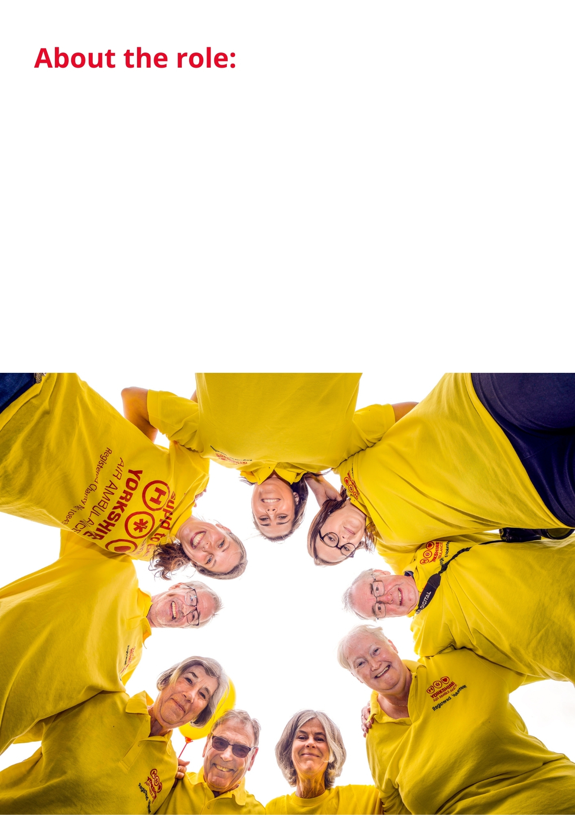

We are currently seeking to recruit an experienced and professional Regional Fundraising Manager for the West and South Yorkshire regions. The main purpose of this role is to develop, implement and deliver the fundraising strategy across West and South Yorkshire.
To lead the fundraising activity across the regions, ensuring that the annual financial income & expenditure targets are achieved.
We are also looking for someone with Business Development experience to assist with developing the profile and income of the South Yorkshire region specifically.

If you would like to be part of this high-profile, successful regional Charity and think that your skills and experience fit the bill for this exciting role… we look forward to hearing from you!

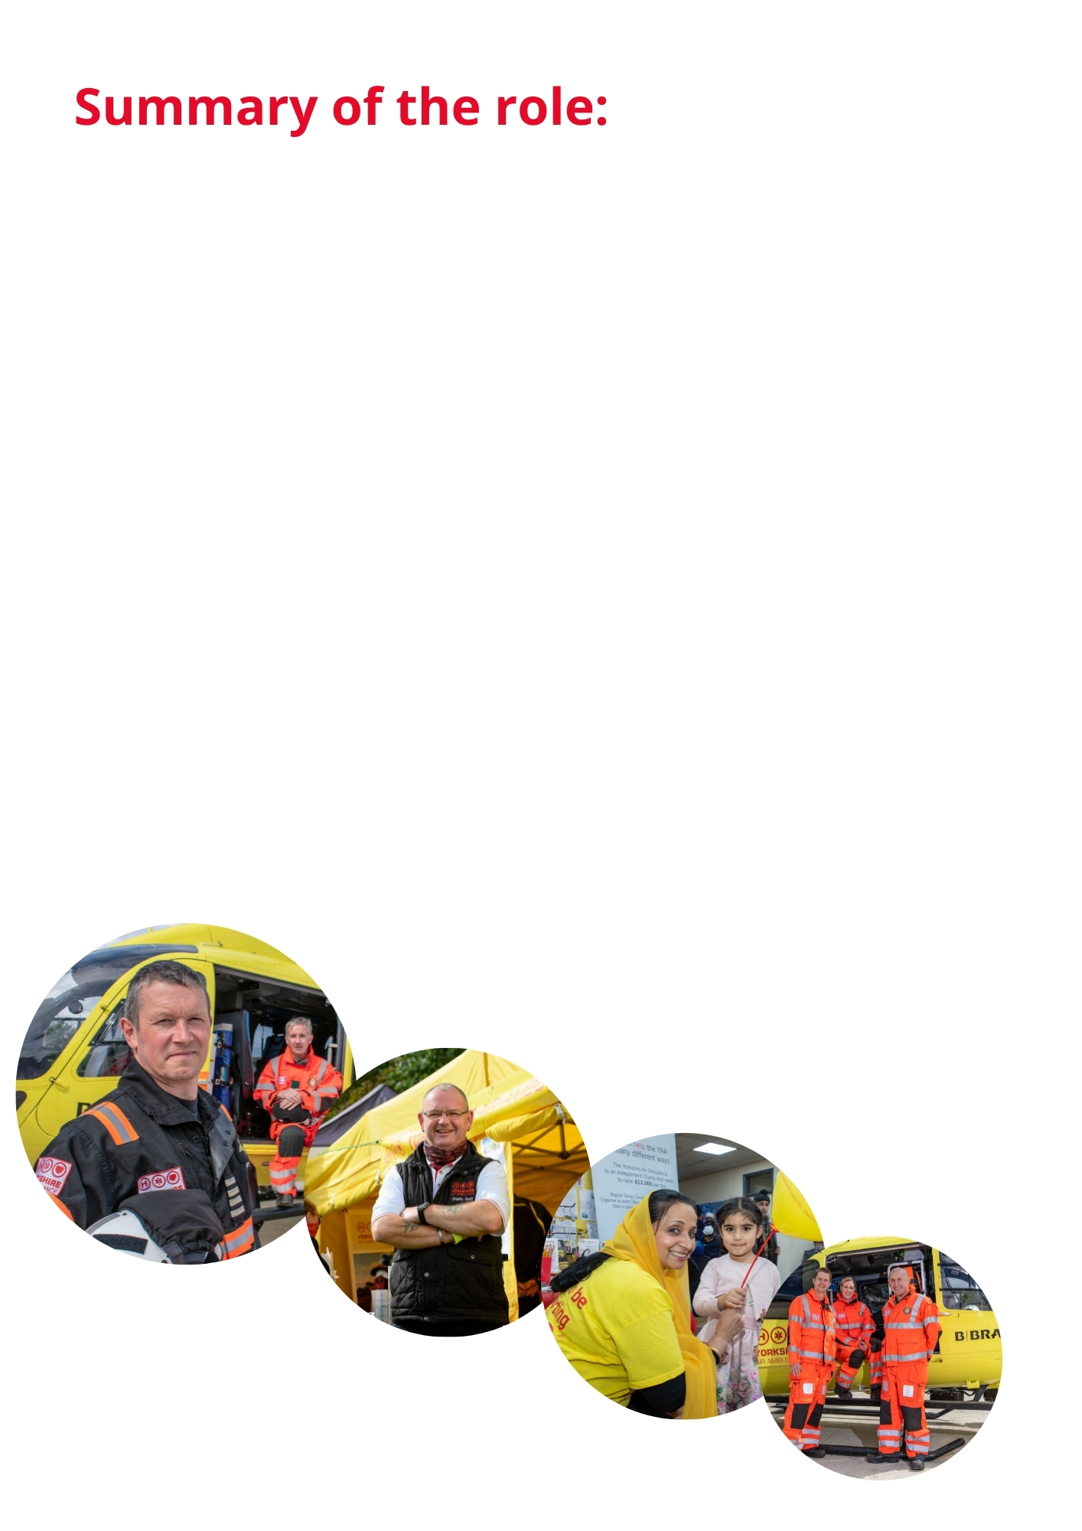

JOB TITLE | Regional Fundraising Manager- West and South Yorkshire.
LOCATION | Home based (travelling primarily in the West and South Yorkshire area).
REPORTING TO | Director of Fundraising- West & South Yorkshire.
HOURS | Full Time (flexibility essential, with frequent evening and weekend work required).
ADDITIONAL INFO | Requirement to work some unsocial hours both in the evenings and weekends. A vehicle is available with this role.
JOB PURPOSE | To develop, implement and deliver the fundraising strategy across West and South Yorkshire.  To lead the fundraising activity across the regions, ensuring that the annual financial income & expenditure targets are achieved.

Key Responsibilities and Duties
- To develop, implement and deliver the fundraising strategy for West and South Yorkshire.

- To forecast, prepare and deliver the annual income and expenditure budget for the region.

- To work alongside the Director of Fundraising- West & South to implement a growth & Corporate strategy for South Yorkshire.

- To recruit, train, develop, lead, manage the West and South Yorkshire fundraising team and ensure all staff know what is expected of them and have the tools to deliver their objectives.

- To develop staff through the annual appraisal process and ensure all staff have SMART KPIs.

- To act as an ambassador for the Yorkshire Air Ambulance by undertaking public speaking engagements, attending cheque presentations, representing the charity at a variety and diverse mix of events and groups throughout West and South Yorkshire. These events can be of a corporate or community nature. Responsibilities will also include showing visitors around our ASU facility at Nostell Priory. Planning, organising and marshalling helicopter PR visits to events when necessary.

- To raise awareness of the charity and maximise all income-generating opportunities across West and South Yorkshire.

- To focus on providing excellent donor stewardship, creating long lasting relationships with supporters, including individuals and groups.

- To generate leads for key corporate contacts and new business partnerships to assist in delivering the annual income target for this income stream.

- To work with the Trusts & Legacies department to assist in delivering their annual income budgets.

- To assist the Regional Fundraising Directors in implementing the Legacy Fundraising Strategy.

- To plan & attend regional meetings/planning meetings as required.

- To ensure all systems and processes are followed in accordance with operating procedures.

- To always observe Health and Safety requirements and comply with the Charities policies and procedures.

- To deal with complaints in accordance with the Charity’s complaint policy and process, reporting them to the Director of Fundraising if necessary.

- To utilize the CRM system to effectively manage our donor base, maximising income.

- To ensure we meet the requirements of GDPR, data protection and security.

- To be responsible for handling cash and dealing directly with the public on behalf of the charity. To comply with the Charities financial systems and processes and to ensure effective governance.

- To undertake other duties and training as may reasonably be required from time to time.

- To undertake fundraising projects as requested by the Director of Fundraising- West & South Yorkshire.

Skills and Abilities:
Planning for the Future - Plans to achieve their objectives within timescale, balancing short and long term requirements. Identifies opportunities and barriers and considers the implications of actions.
Communicating with Others - Pitches communication at the right level both verbally and in writing and checks for understanding. Good listening skills. Uses information to influence others. Able to give tough messages when required.
Leading a Team - Setting direction for a team and motivating them to deliver results.
Generating Ideas - Continually seeking to improve the service offered by the team by coming up with improved systems and processes and added value activities. Considers pros and cons and impact on team and resources.
Building Relationships - Works well with others. Co-operates willingly with others. Able to quickly build effective relationships with all levels both internally and externally and meet the needs of the individual. Treats others with dignity and respect and able to gain the trust of others. Builds strong relationships with others.
Flexibility and Adaptability - Adopts a flexible and adaptable approach. Recovers well from setbacks and resistance from others. Remains calm under pressure and focused on the task. Encourages others to do the same.
Making Decisions - Anticipates issues and takes action to address underlying cause. Reaches effective decisions by gathering and analysing relevant information balancing cost, benefit and risk implications. Considers options, weighs up pros and cons before deciding on action.
Delivering Results - Accepts accountability and ownership. Ensures self and team delivers on time and to required standard. Has high standards and leads by examples. A good role model. Creates enthusiasm in others.
Self-Motivated - Works well on their own or as part of a team. Demonstrates a positive attitude. Energetic and enthusiastic.

Knowledge and Skills Required:
Essential:
- Experience of working to a sales/fundraising target and managing an expenditure budget.

- Experience of developing and maintaining long term customer/donor relationships.

- Experience of Business Development.

- Experience of writing budgets for income and expenditure.

- Experience of managing a sales/ fundraising team.

- Experience of presenting to a variety of groups.

- A willingness to travel and work unsocial hours both in the evenings and at weekends.

- Computer literacy (Microsoft Office Outlook/Word/Excel/PowerPoint/Zooms & Teams).

- Have suitable home based accommodation/office space.

- Clean driving license.

Desirable:
- Experience of project/event management.

- Residing within the West or South Yorkshire area.

- Experience of working from home.

- Knowledge of Health and Safety/Risk Assessment.

- Knowledge of a sales/fundraising database.

- Educated to degree level or equivalent qualification or practical experience.

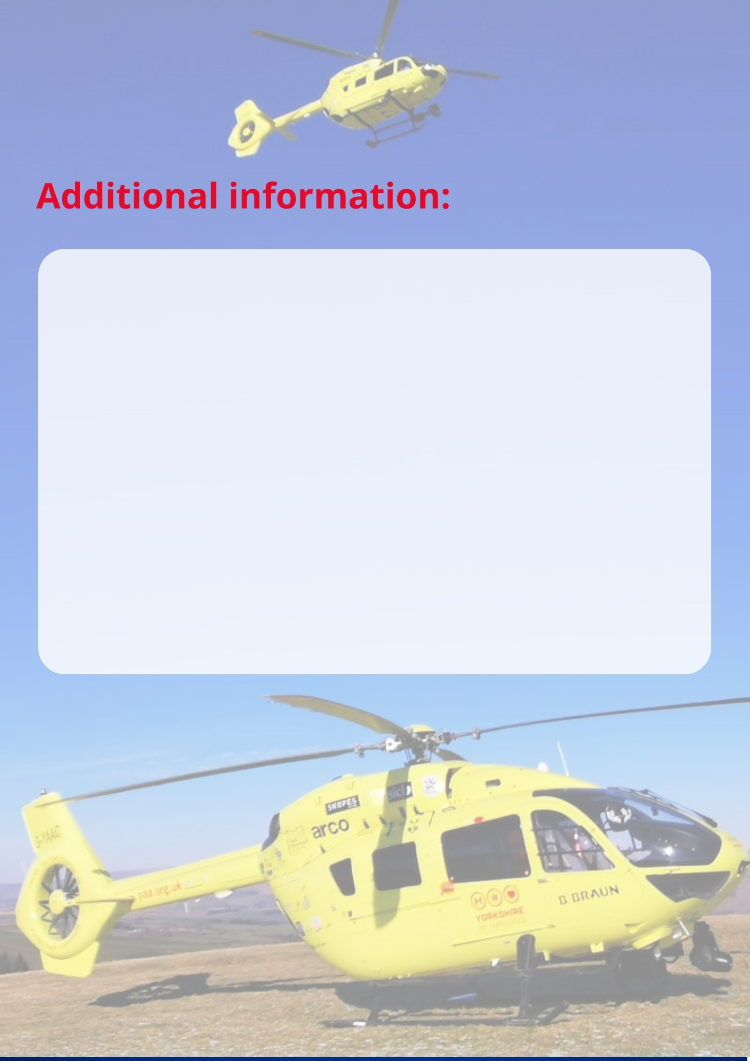

- Salary £28,000 - £30,000.

- Discretionary annual staff bonus scheme based on the Charity’s financial performance and personal KPIs after satisfactory completion of the six month probationary period.

- 22 days paid holiday per annum plus statutory Bank Holidays (pro-rata).

- Contributory pension scheme.

- Confirmation in post subject to completion of a successful six month probationary period.

- Life Assurance.

- If you wish to discuss the job role in more detail, please contact Jenny Jones on: 07880 389052

To apply for this position:
- Complete the application form (downloadable from our website www.yaa.org.uk)
- Provide a covering letter
- Complete the Equal Opportunities form (optional)

Please email completed applications back to us by forwarding it to: recruitment@yaa.org.uk
To discuss in more detail, please contact Jenny Jones on: 07880 389052

Deadline: Thursday 7th October 2021, 12 noon.
First Interviews to take place: Friday 15th October.

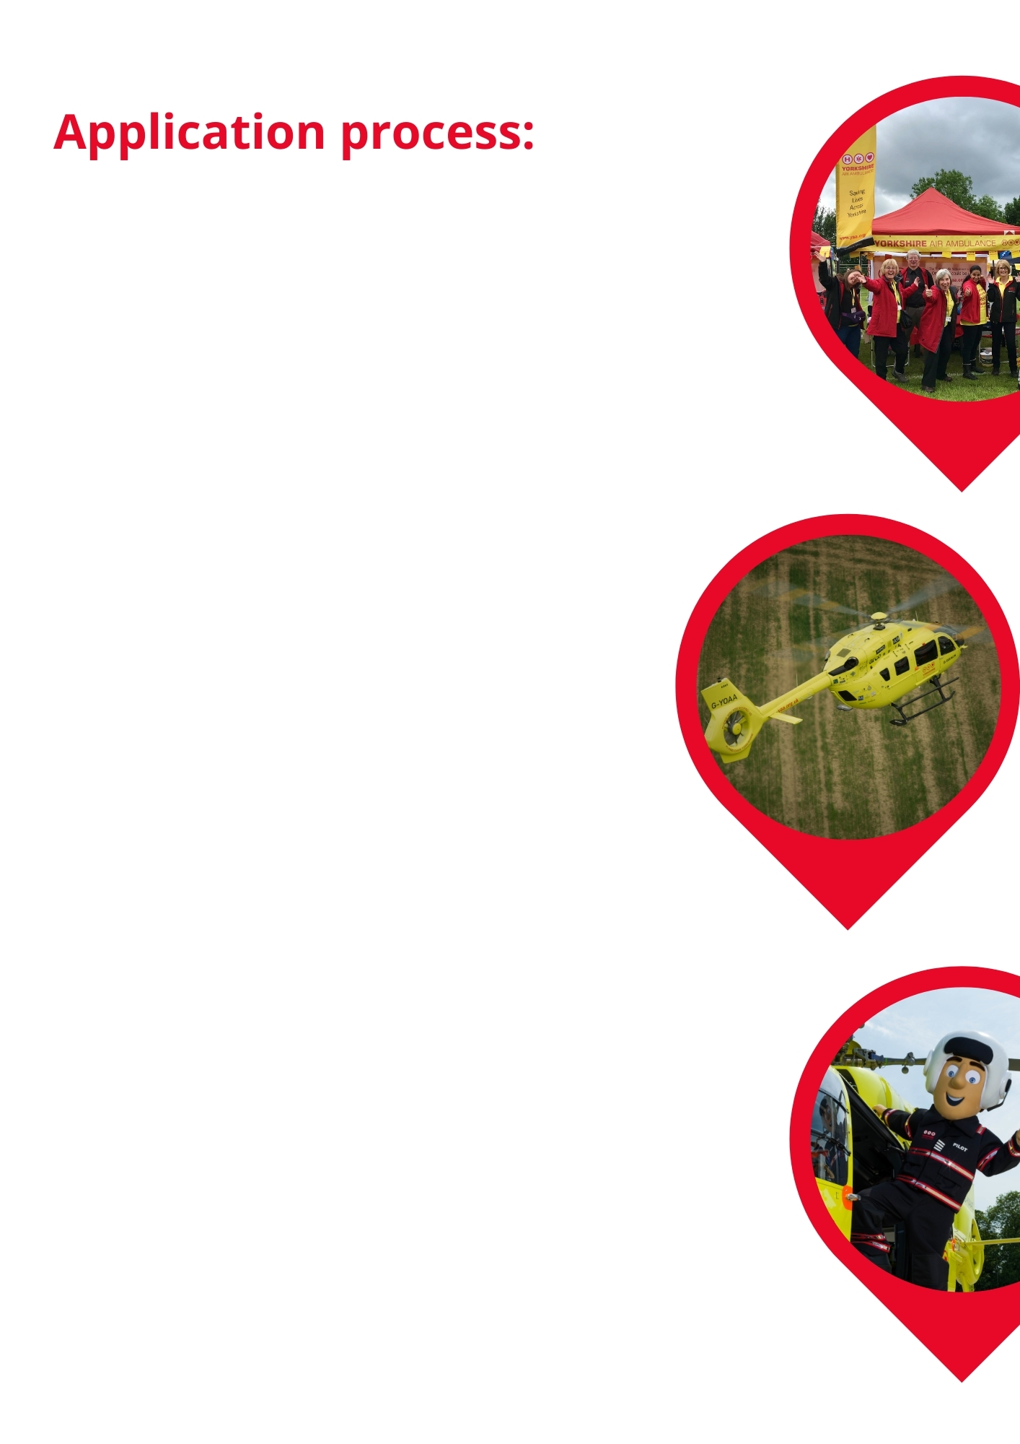

GDPR & our Recruitment Privacy Statement:
The Yorkshire Air Ambulance complies by law with the Data Protection Act 2018 and the EU General Data Protection Regulation. Attached with this pack is a copy of our Recruitment Privacy Statement. This advises you of how the Charity collects and processes your personal data. The Privacy Statement also declares how the Charity will comply with GDPR and the Data Protection Act 2018. Please ensure you download and read the Statement before completing and submitting your application for employment.

