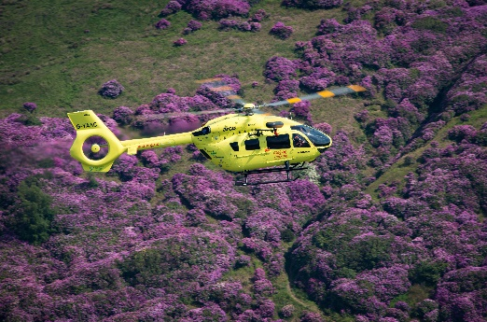
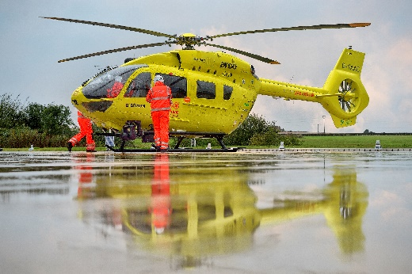
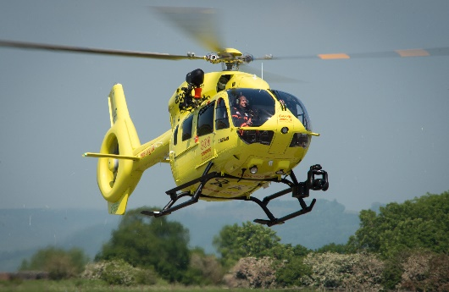

JOB INFORMATION PACK

Line Pilot

Yorkshire Air Ambulance Charity
Cayley House
10 South Lane
Elland
West Yorkshire
HX5 0HQ

01422 237900

BACKGROUND OF YORKSHIRE AIR AMBULANCE

Not everyone realises that the Yorkshire Air Ambulance relies solely on the generosity of individuals and organisations to help save lives across your region. In fact, as an independent Charity we only receive help through secondment of the paramedics from the Yorkshire Ambulance Service NHS Trust. We need to raise £12,000 per day to keep both of Yorkshire’s air ambulances and highly-trained crew in the air. This is the equivalent of £4.4M every single year.

As a rapid response lifesaving emergency service, our air ambulances serve a population of five million people across four million acres. Our two Airbus H145 helicopters operate from Nostell Priory near Wakefield in West Yorkshire and RAF Topcliffe near Thirsk in North Yorkshire, covering the whole of Yorkshire seven days a week, 365 days per year. Flying with NVIS commenced in the summer of 2017 and extends the hours of operation from between 0600 to 2400.

Wherever the air ambulance lands at the scene of an accident, it is a maximum of 20 minutes from a Major Trauma Centre for the patient’s injuries or illness.

Over 7,900 patients’ lives have been changed by the Yorkshire Air Ambulance since the Charity began in October 2000.

JOB ROLE

The structure of the YAA is unusual in so far as we do not have a Chief Executive. The Trustee Board consists of 10 Trustees with different skill sets and expertise that they bring to the Charity. The Chairman is Peter Sunderland MBE, DL and the Vice Chair is Brian Chapman. The Board is very commercially focussed and has a broad spectrum of skills.

Day to day running of the Charity falls under the control of departmental Directors who form our Senior Management Team (SMT). Six SMT members are responsible for the business activity departments of Fundraising, Finance, Marketing & Communications, Operations, and Aviation. We are seeking to recruit a Line Pilot to join our team who, under the direction of a Chief Pilot, will be responsible for the command and operation of one of our Airbus H145 helicopters. Unlike most other air ambulances in the UK, we directly employ pilots to fly the helicopters under our own Air Operators Certificate (AOC).

Operating hours throughout the year are from 6am to midnight with a double shift at our primary airbase from Nostell Priory, near Wakefield, West Yorkshire. We also have a secondary base at RAF Topcliffe, near Thirsk which operates on a 3 on / 3 off, 12 hour shift from 7am till 7pm each day. The successful candidate will be employed at our Nostell base.
If you would like to be part of this high-profile, successful regional charity and think your skills and experience fit the bill for this exciting role… we look forward to hearing from you!

JOB DESCRIPTION
JOB TITLE | Line Pilot
LOCATION | Nostell ASU, Foulby, near Wakefield, with infrequent duties from RAF Topcliffe near Thirsk.
REPORTING TO | Chief Pilot
HOURS | Fixed roster, with either a variable nine-hour shift to cover the operational period between 06:00 and 24:00 Monday to Friday or a 12 hour shift between 09:00 and 21:00 at the weekends.  Occasional variations to this pattern may be requested, but duty time will never be more than as permitted under the approved FTL scheme
ADDITIONAL INFO | Extra duties may sometimes be requested to provide cover for unforeseen sickness and holiday relief. Whenever these shifts increase work hours beyond the usual rostered FDP per six-week period, TOIL will be granted or additional payments made.  Suitable accommodation is provided free of charge by the Charity at both air bases to manage fatigue, but it is anticipated that the successful candidate shall be willing to relocate to Yorkshire.
HOLIDAYS | 22 plus 8 in lieu of statutory/public holidays. A percentage of the holiday entitlement will be pre-booked in order to manage the roster, and a proportionate number of weekends and bank holidays are rostered as duty days.
JOB PURPOSE | To carry out line flying duties as required by the Yorkshire Air Ambulance

Main Duties:
- As aircraft commander, to ensure all flying tasks are carried out in a safe and efficient manner in accordance with the Charity’s Operations Manual, in addition to any regulations as laid down by the Air Navigation Order and/or EASA as amended by legislation.

- Ensure that, during periods of duty, you manage and organise the Operating Base in an effective manner; briefing crews on their HEMS responsibilities and maintaining the high personal and professional standards expected from any employee of the Yorkshire Air Ambulance.

- To ensure personal currency in all respects with regard to Flight Crew License, Aircrew Medical, License Proficiency Check (LPC), Operator Proficiency Check (OPC), Line Check, Emergency & Safety Equipment Check (E&SE) and other checks as required by the regulations before carrying out any flight on behalf of the Yorkshire Air Ambulance.

- You may on occasion be required to carry out duties of a different nature either in addition to, or instead of, your normal duties. You will not be assigned duties or asked to perform services which it is believed are unreasonable or you cannot reasonably perform, or which are inconsistent with the position you hold.

Knowledge and Experience required:
Essential
- Either a current ATPL(H) or CPL(H) with Instrument Rating
- A minimum of 1500 hours as pilot-in-command of aircraft
- A minimum of 500 hours as pilot-in-command of helicopters gained VMC overland with significant low flying experience
- 40 hours VFR at night as pilot in command
- CAA Class 1 Medical
- Lives in, or prepared to relocate to the Yorkshire region
- Fluent English, driving licence, passport, right to work in the UK.
Desirable
- Previous experience in a similar role
- H145 type rating
- NVIS experience
- TRI/TRE qualification (Additional Responsibility Allowance paid for these qualifications)

Skills and Abilities:
Communicating with others – Pitches communication at the right level both verbally and in writing and checks for understanding. Good listening skills. Uses information to influence others. Able to give tough messages when required.
Building Relationships – Works well with others. Cooperates willingly with others. Able to quickly build effective relationships with all levels both internally and externally and meet the needs of the individual. Treats others with dignity and respect and able to gain the trust of others and build strong relationships with others.
Flexibility and Adaptability - Adopts a flexible and adaptable approach, taking on board the opinions of colleagues. Recovers well from setbacks and resistance from others and remains calm under pressure and focused on the task. Encourages others to do the same.
Making Decisions - Anticipates issues and takes action to address underlying cause. Reaches effective decisions by gathering and analysing relevant information balancing cost, benefit and risk implications. Considers options, weighs up pros and cons before deciding on action.
Delivering Results - Accepts accountability and ownership. Ensures that they and the team deliver on time and to required standard. Has high standards and leads by examples. A good role model. Creates enthusiasm in others.
Self-Motivated - Works well on their own or as part of a team. Demonstrates a positive attitude. Energetic and enthusiastic.

Additional Information:
- Salary details available upon request (dependent on skills and experience)
- Discretionary annual staff bonus scheme based on the Charity’s financial performance
- Mileage expenses for use of own car
- Contributory pension scheme
- Private Medical Insurance
- Life Assurance
- Confirmation in post subject to completion of a successful 6-month probationary period
- Interviews will take place at Cayley House, Elland, HX5 0HQ early April (TBC)
- Start date for the successful applicant to commence in June 2020
- The successful applicant will be subject to a full Disclosure and Barring (DBS) check

If you wish to discuss the job role in more detail, please contact:
Steve Waudby, Director of Aviation, on 07811269466

Closing date for applications: 31st March 2020

To apply for this position, please fully complete the Application Form (downloadable from our website www.yaa.org.uk or available upon request by calling 01422 237900).
Returned applications should be forwarded with a covering letter including current package and salary expectations, and a copy of your CV to Katherine Humphreys, HR Officer to k.humphreys@yaa.org.uk
We would prefer completed applications to be emailed back to us.
For further information about the Yorkshire Air Ambulance, please visit www.yaa.org.uk .

